**Predicting restaurant tips using predictive analytics on Excel.**

Q1) Use the restaurant tips file for the analytics using excel

Ans) In the restaurant tips file,I have added a separate column which is the actual bill. The column actual bill is the summation of values from total Bill and Tip.The below mentioned is the pivot table which has the information of sum of actual bill,Number of Members for Dinning,Total Members for Dinning and the Count of smokers

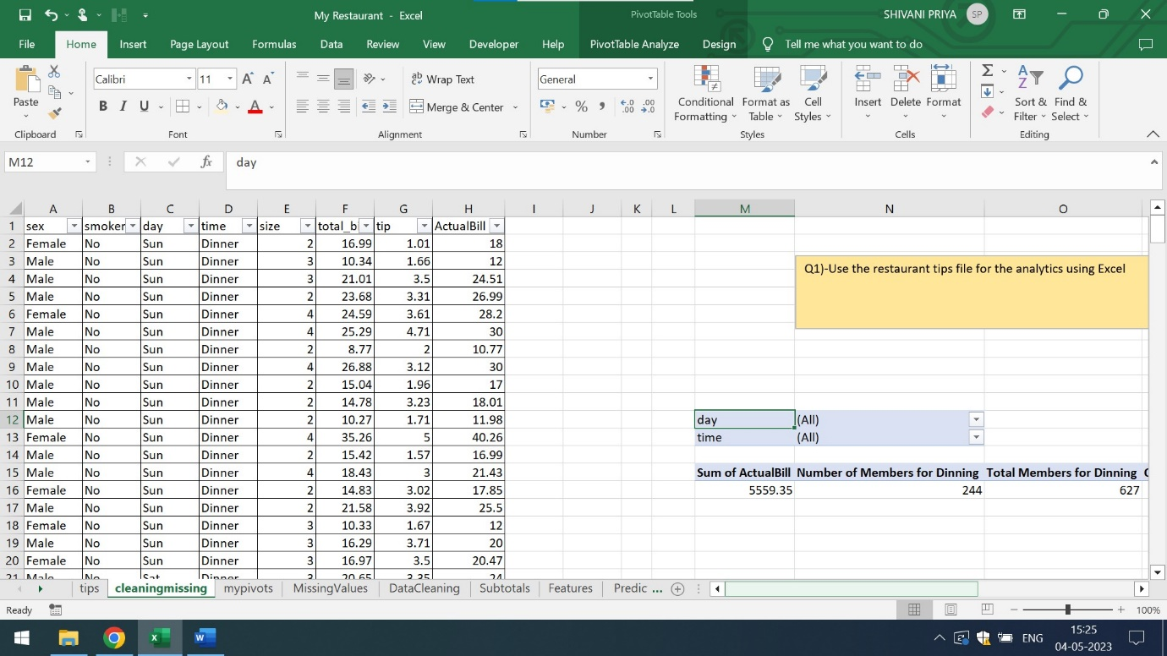

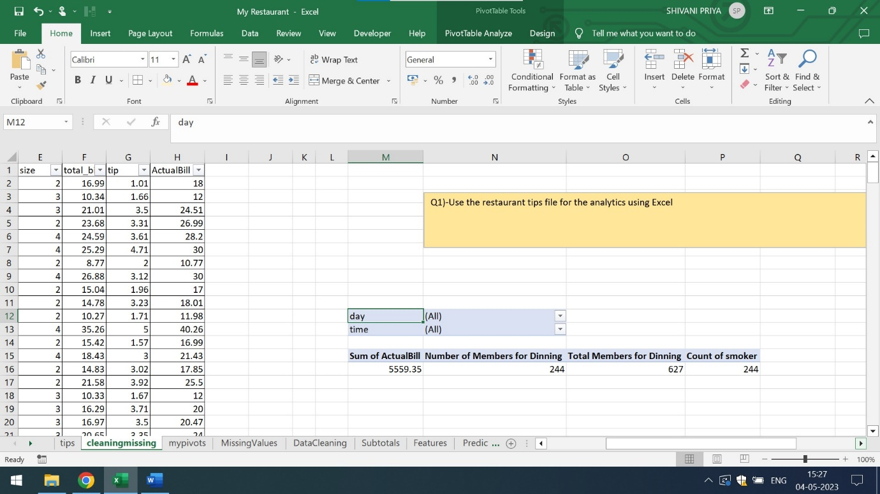

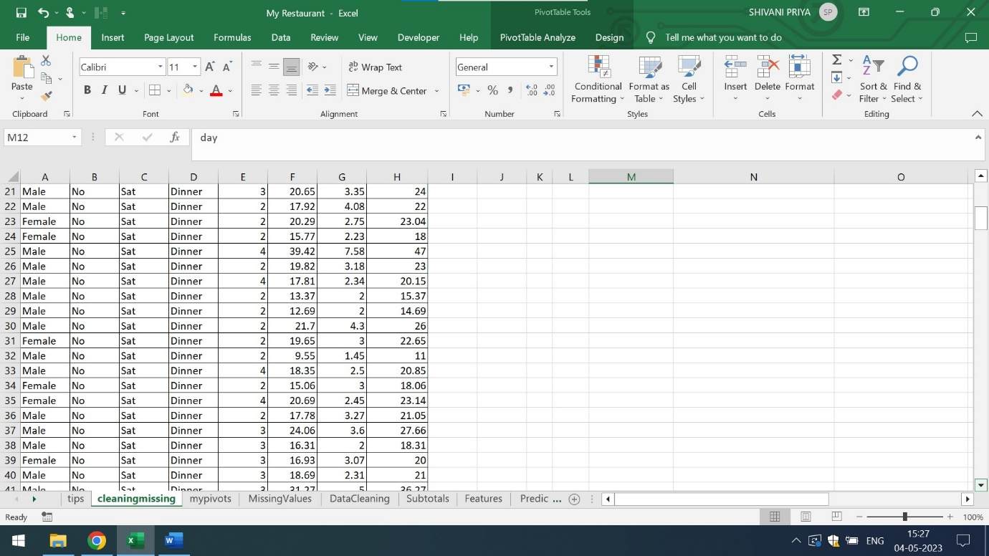

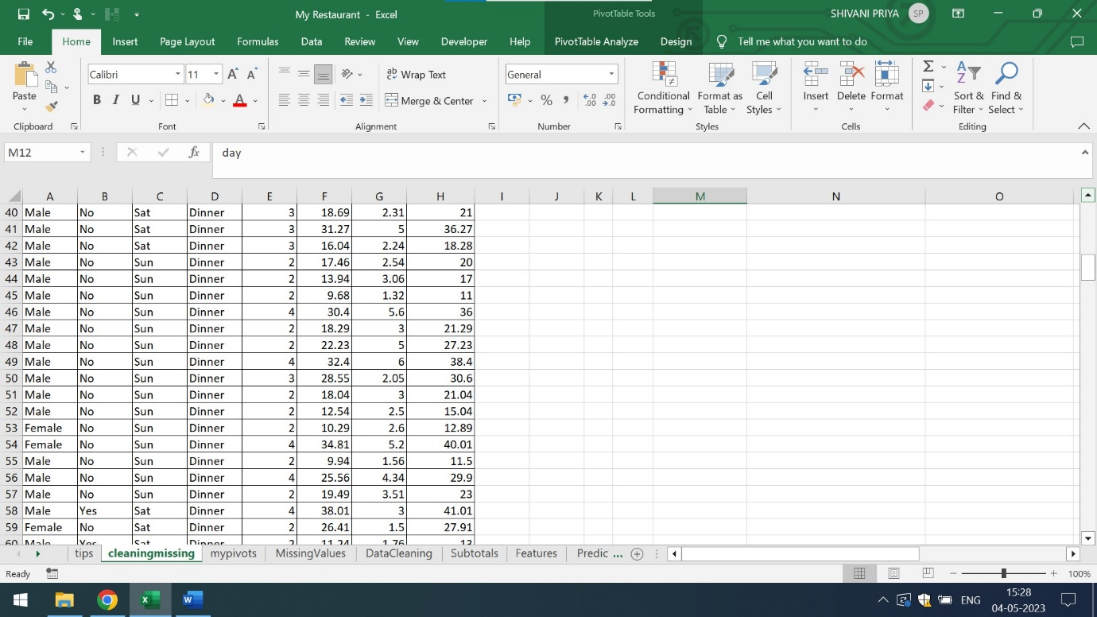

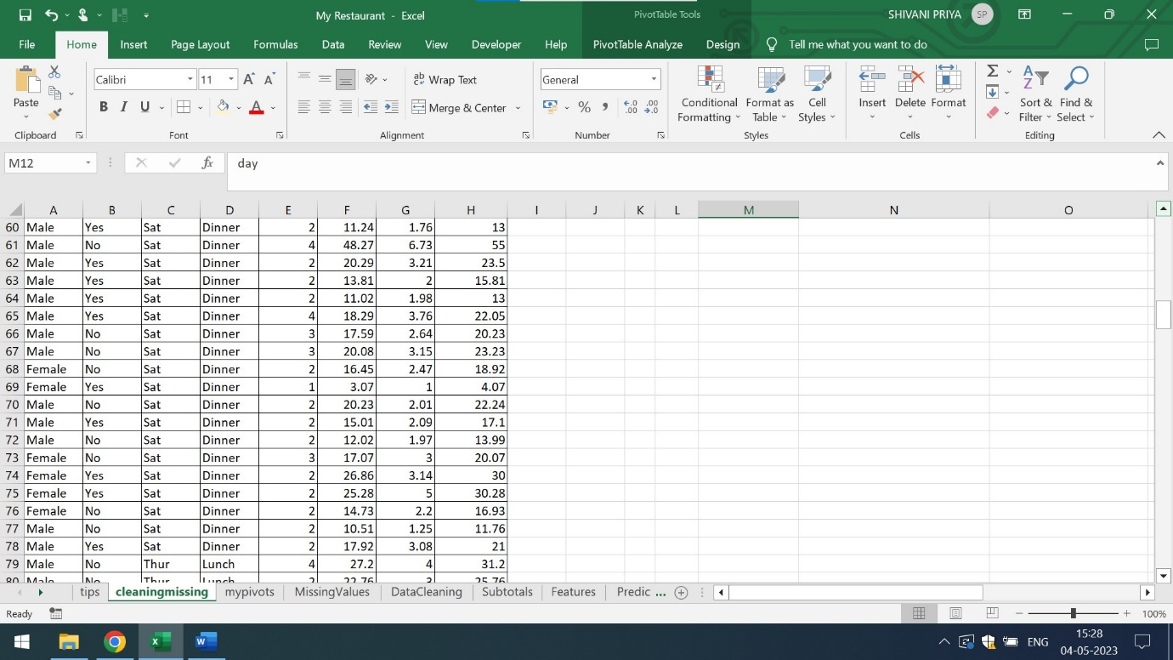

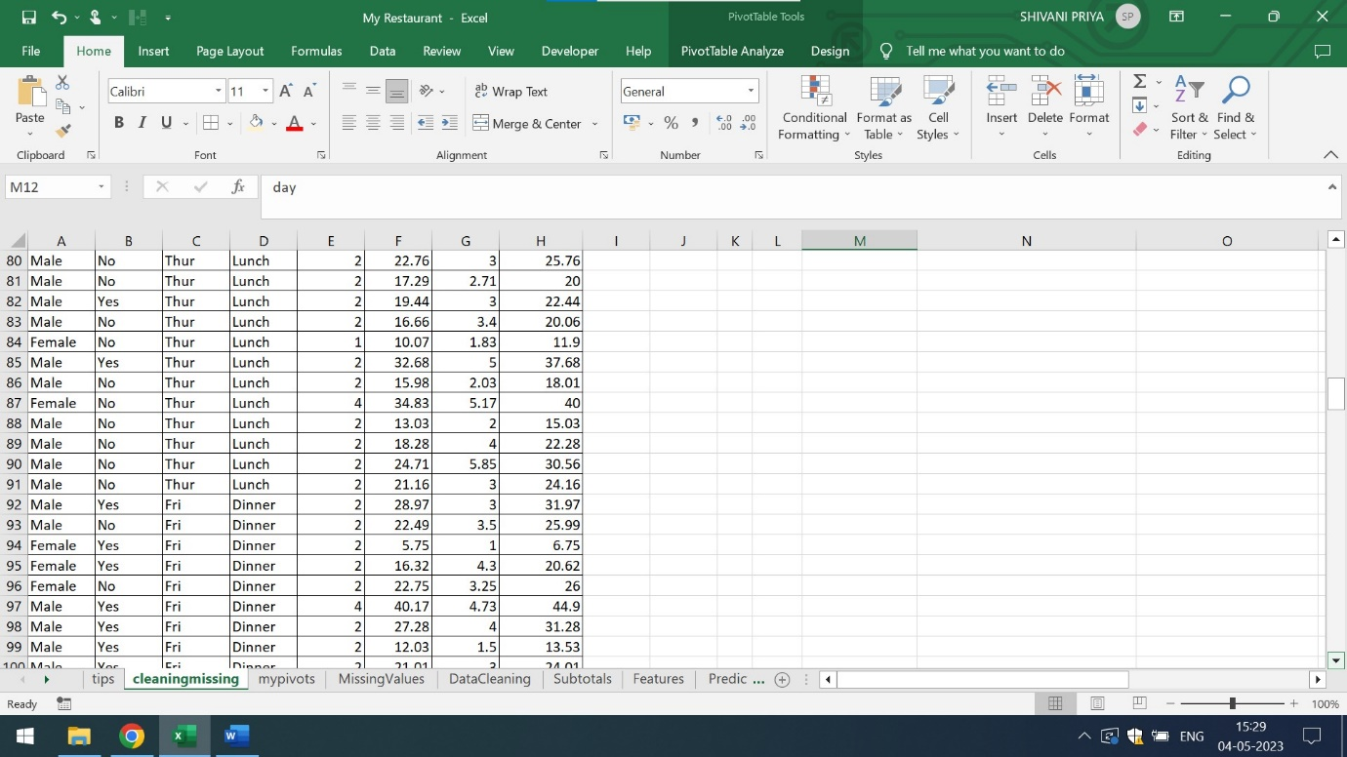

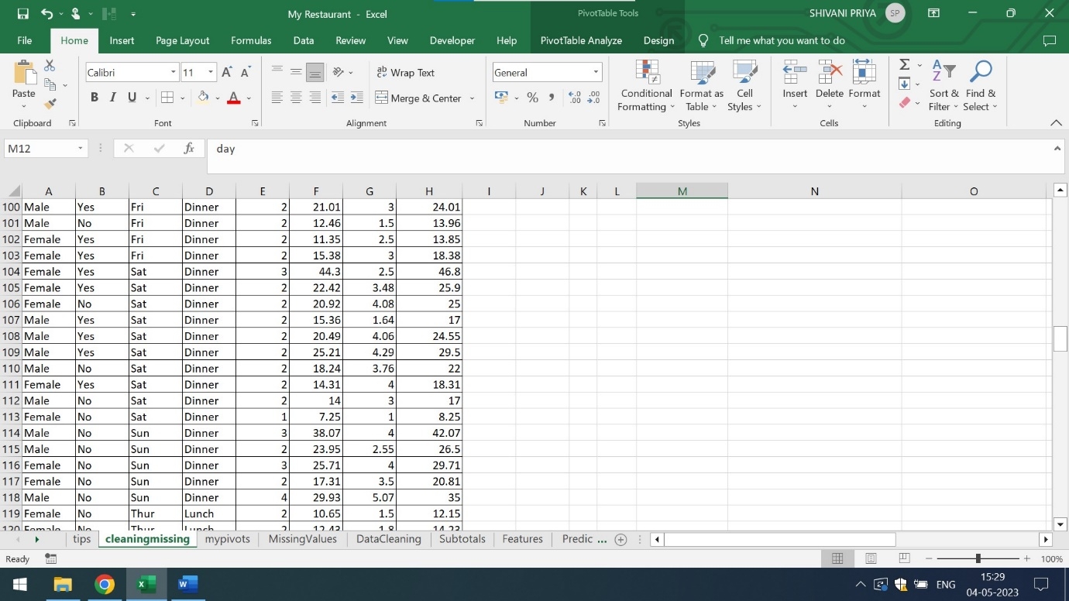

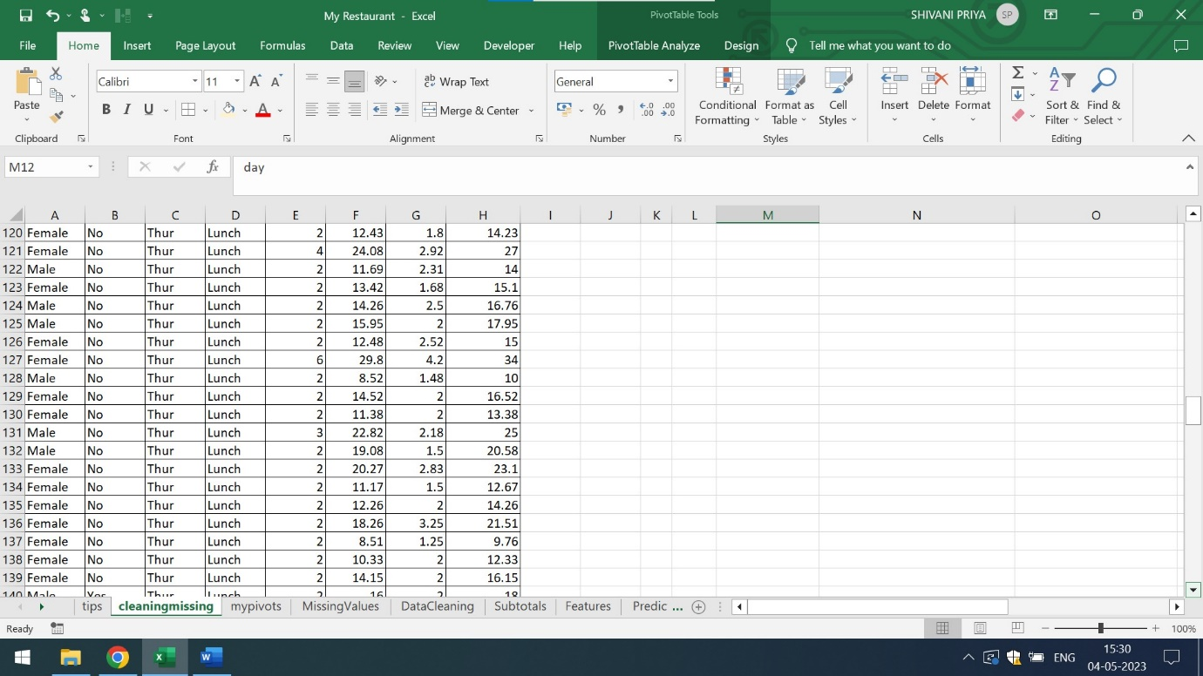

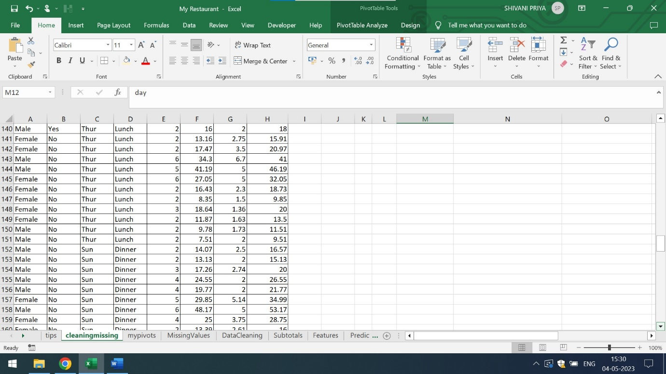

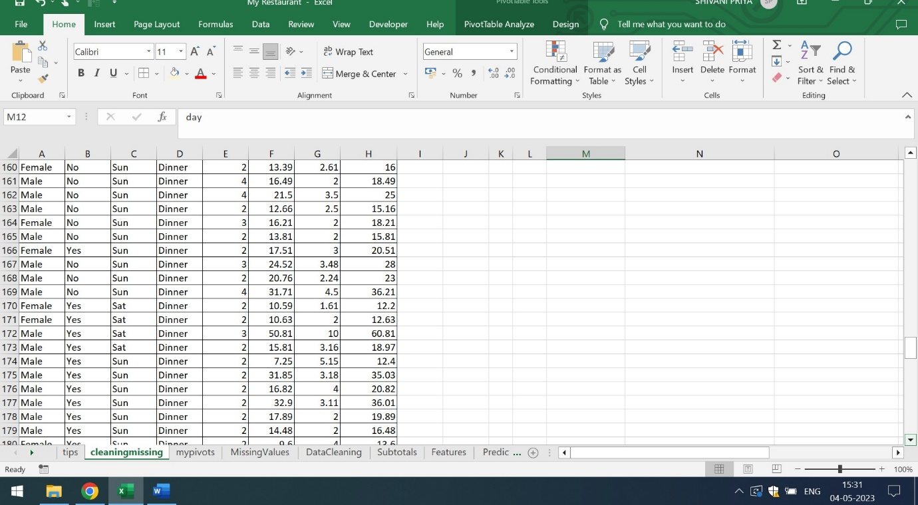

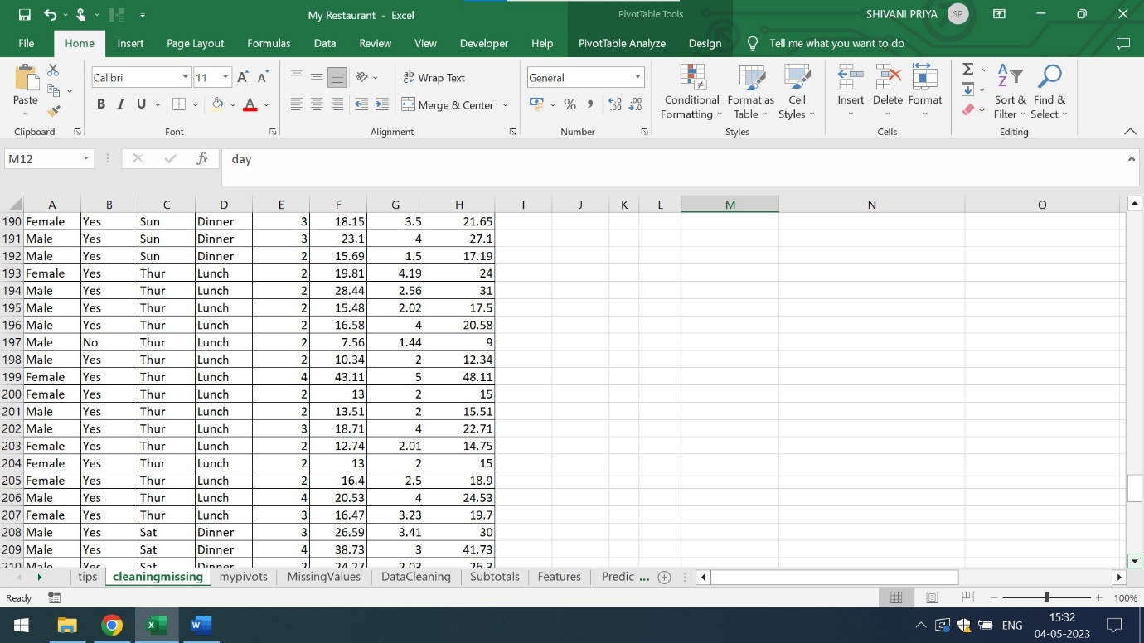

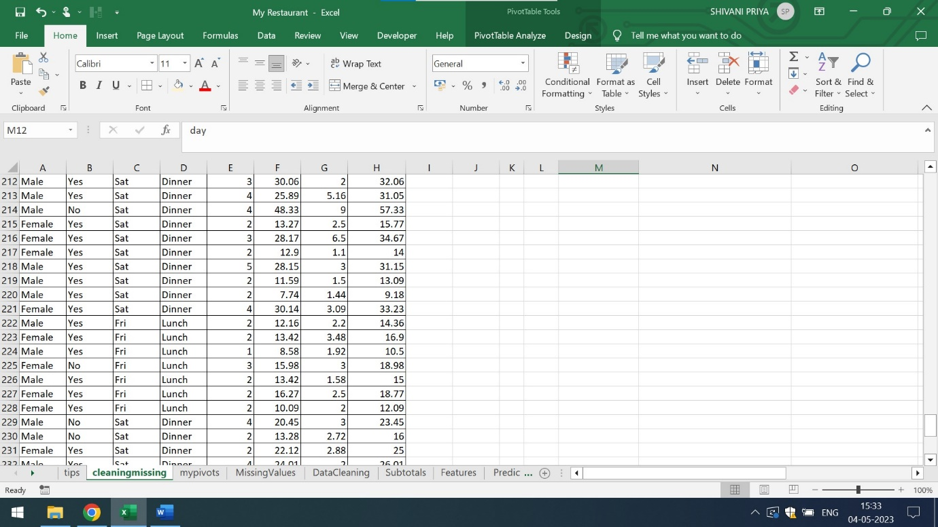

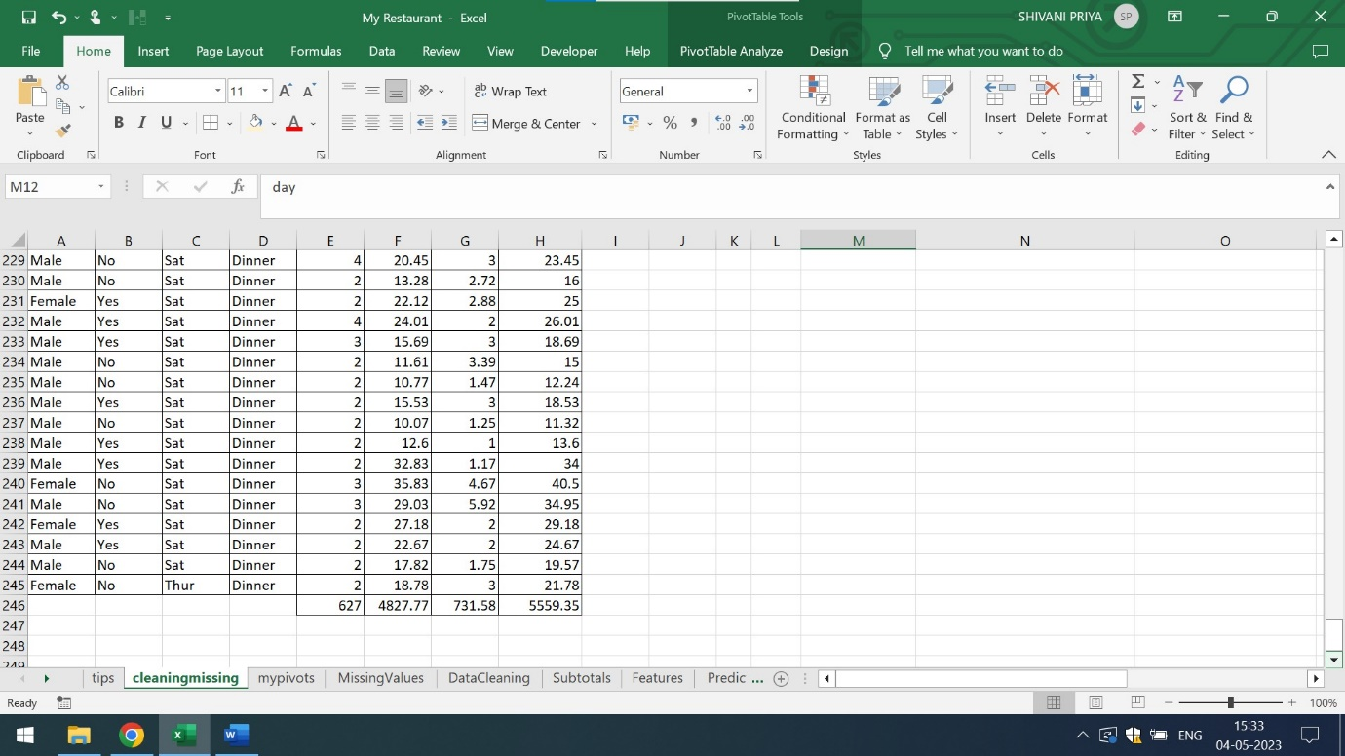

Q2) Find out if there are missing values and clean the data

Ans) From the given dataset by using the concept of filter,I analyze that there are no NAN

Values in the given columns. Hence, there are no missing values in the dataset. However, for data cleaning I am using the concept of removing duplicates in size,total bill and tip columns

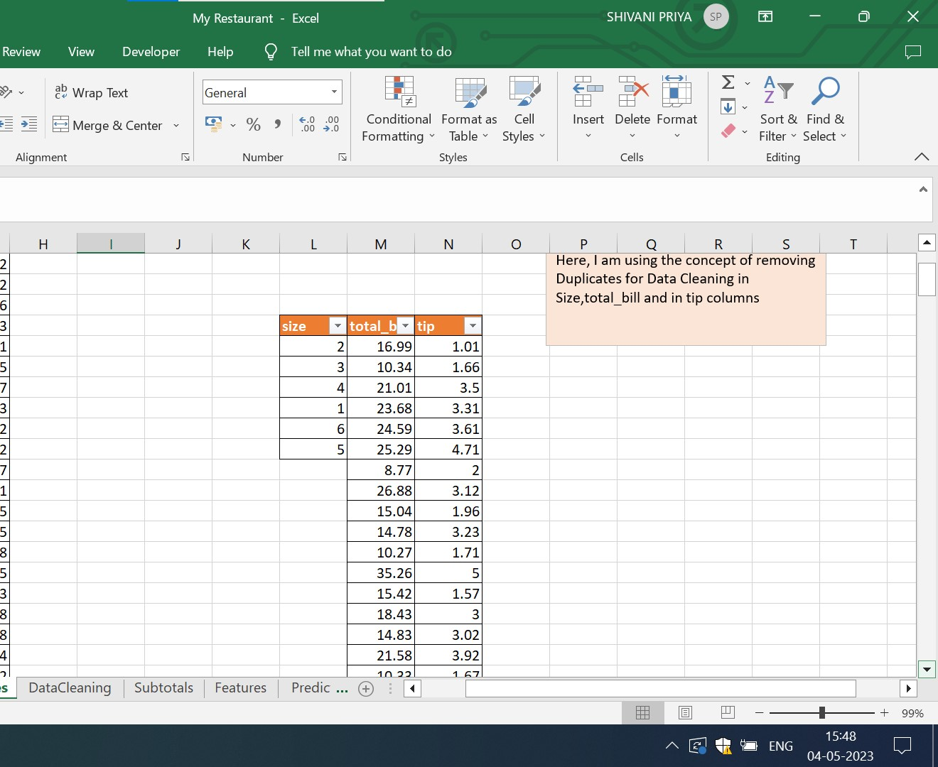

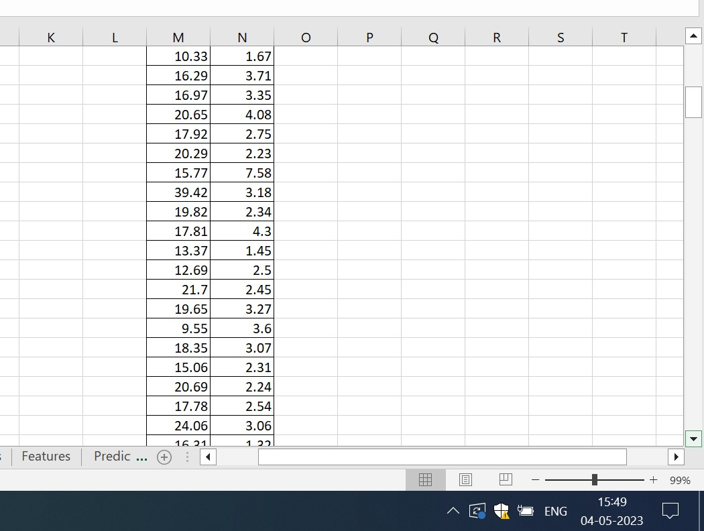

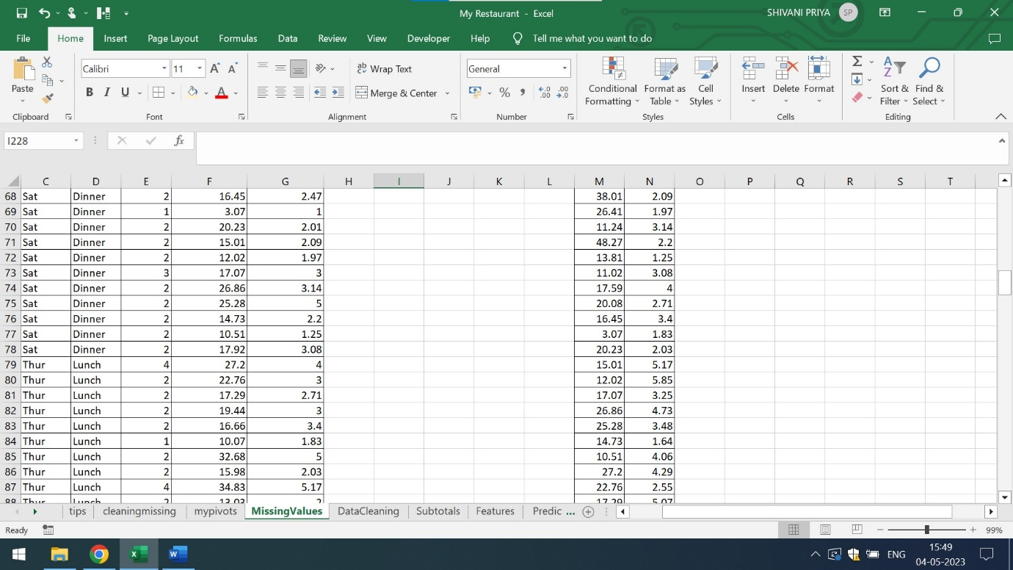

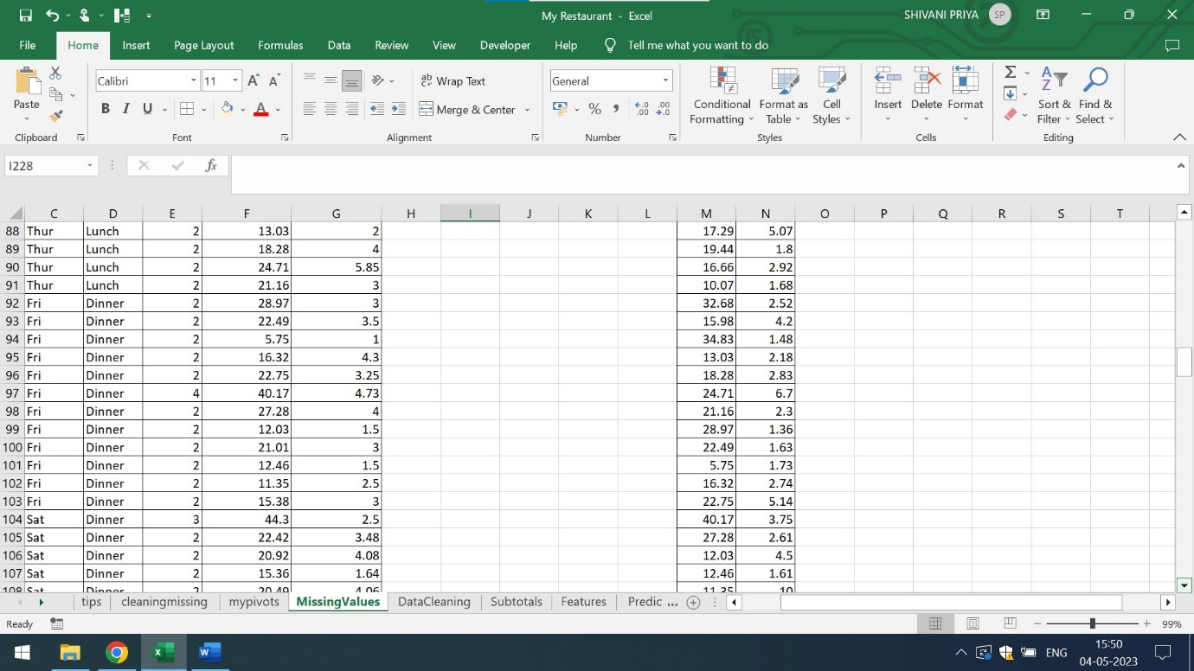

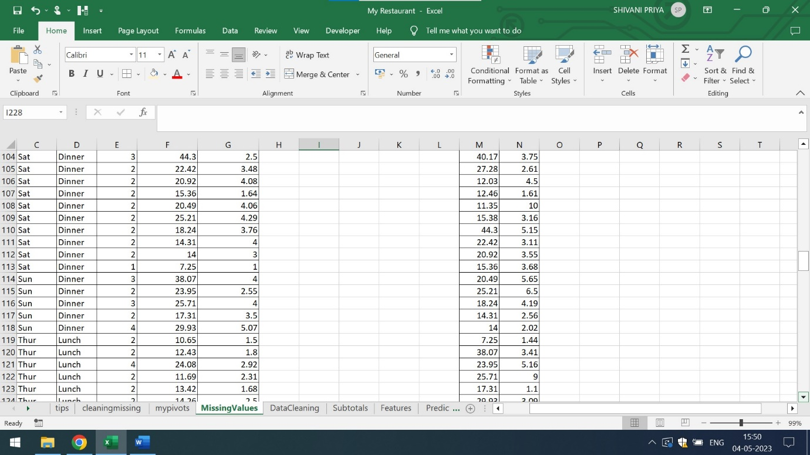

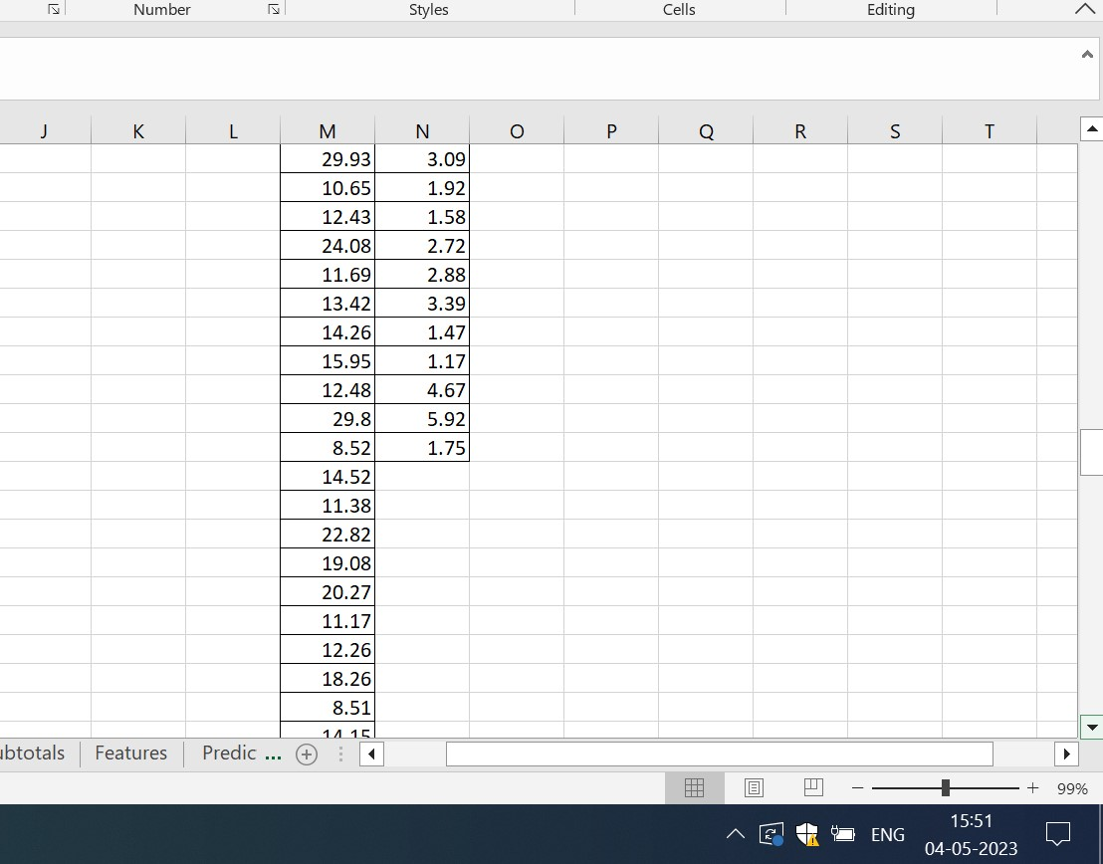

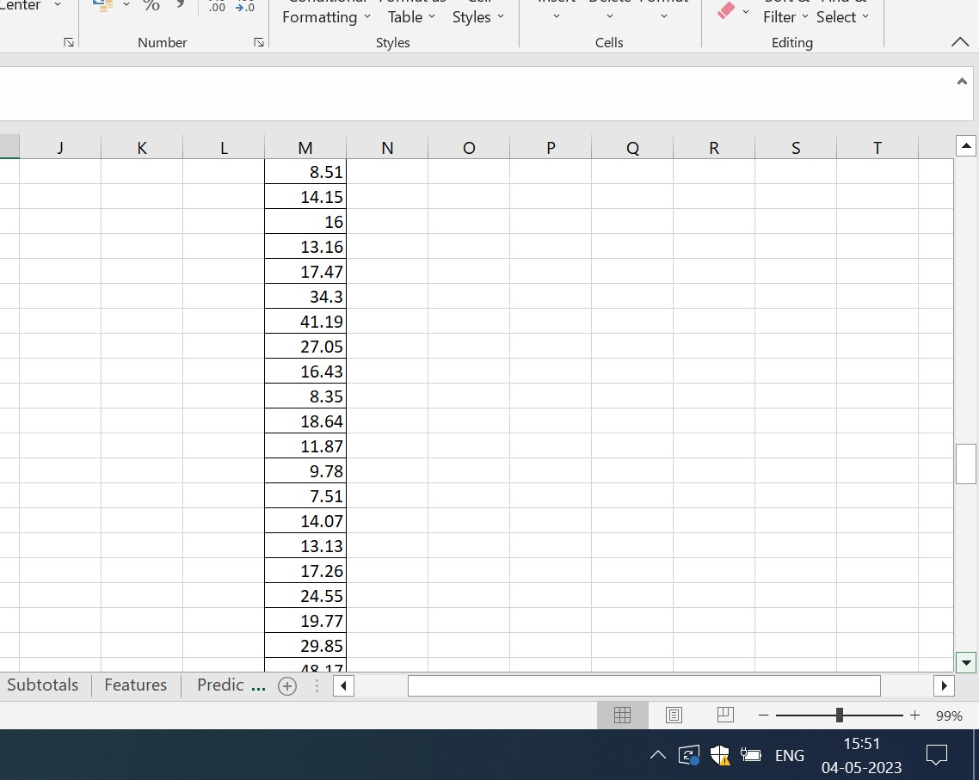

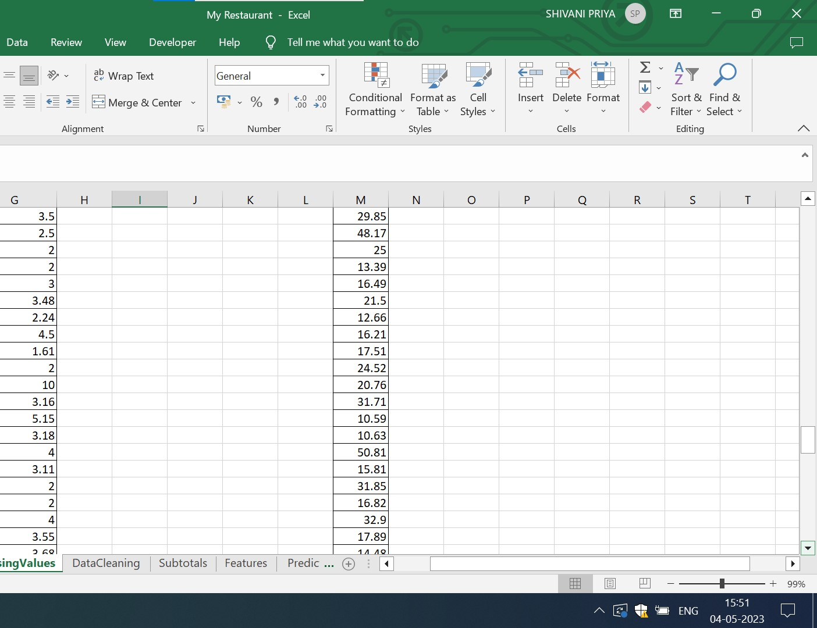

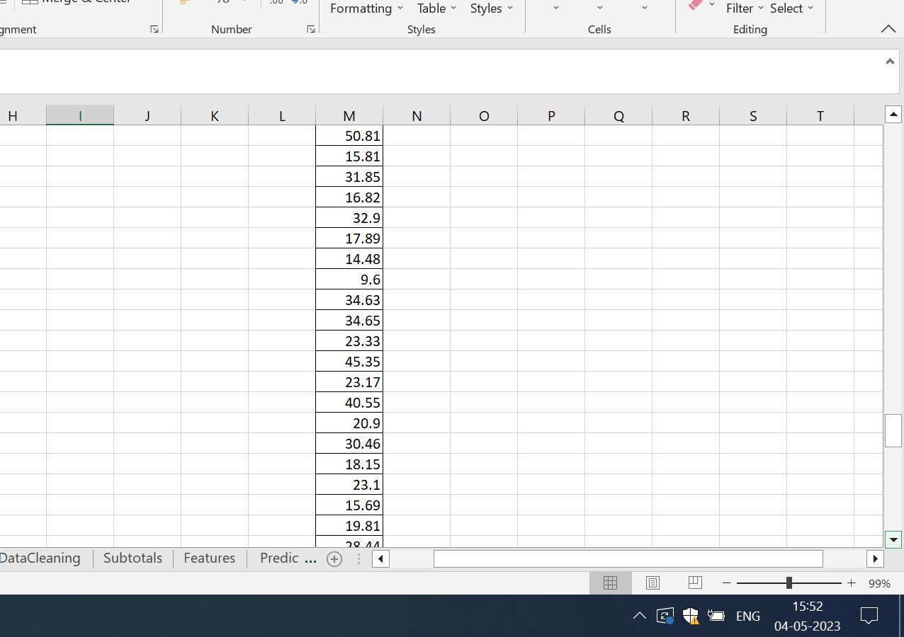

The below attached is the screenshot of the data cleaning where the columns day,time,size,total bill,tip and actual bills are clubbed by Group By concepts

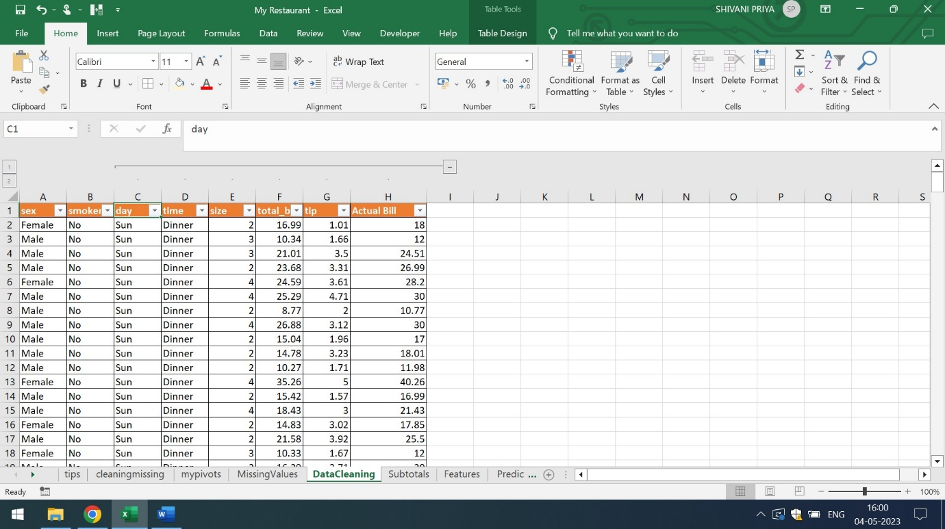

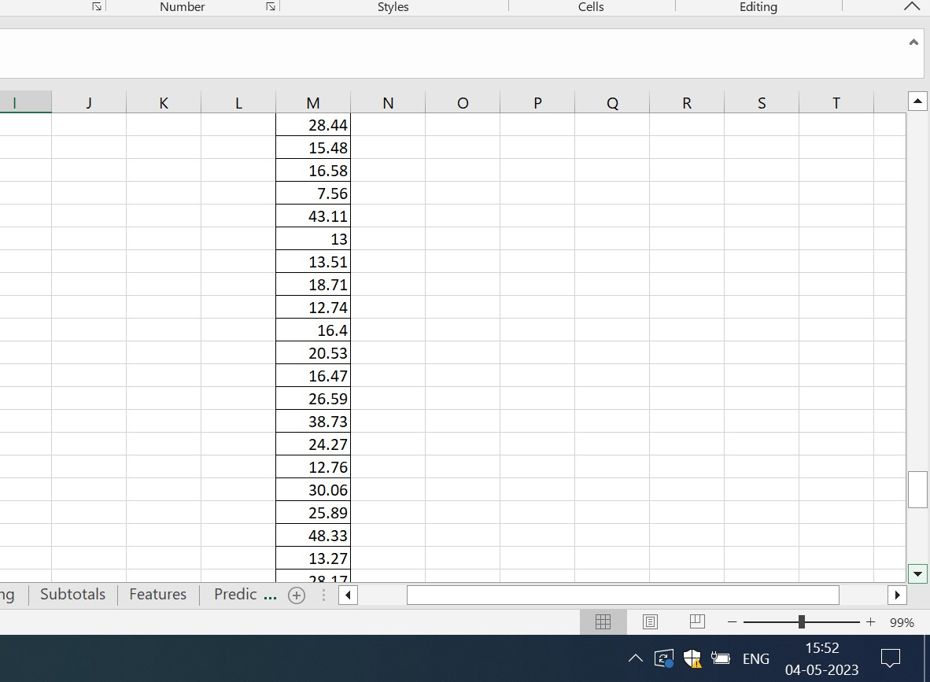

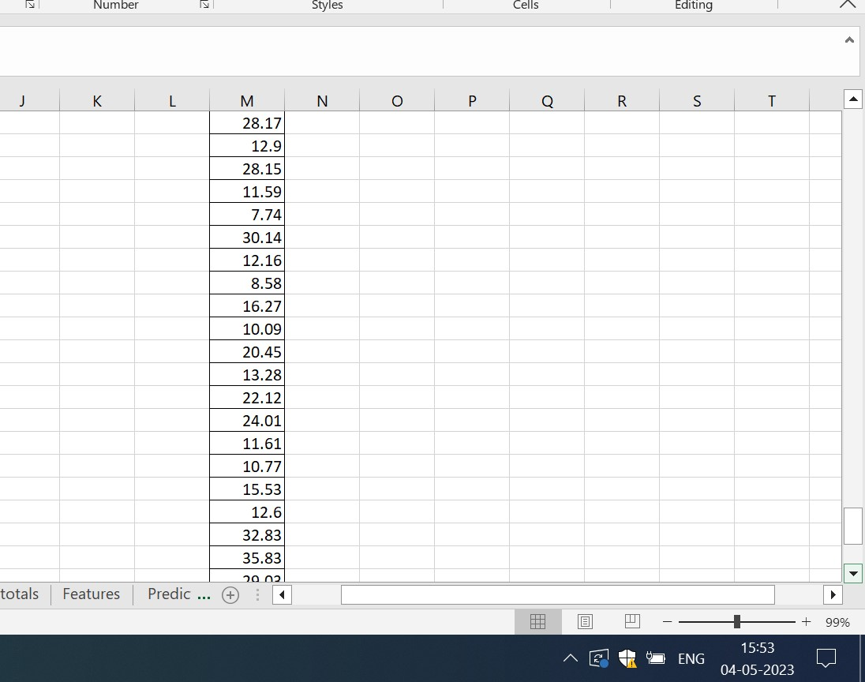

When the user clicks on – symbol,only first two columns are visible

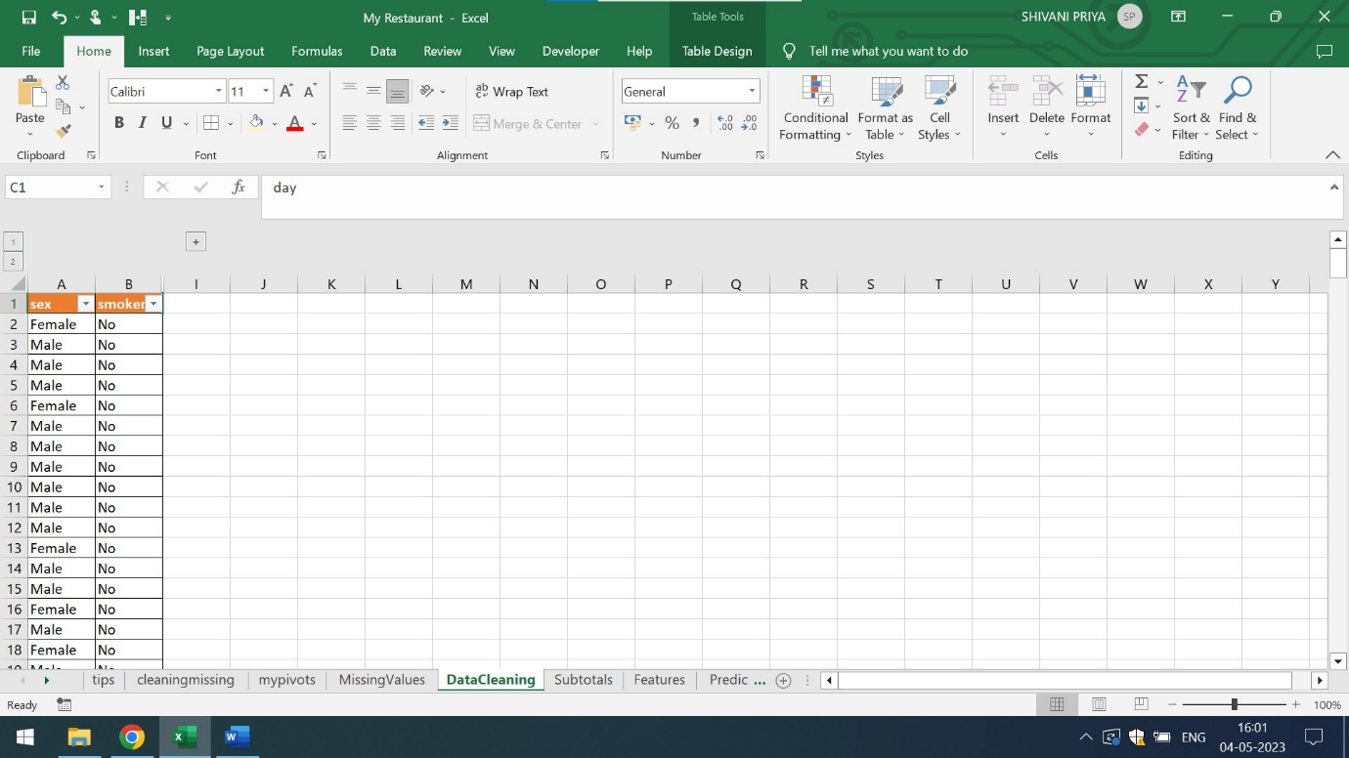

For data cleaning, one can also use the concept of subtotal. The below mentioned screenshots shows the subtotal of Actual Bill for Friday Dinner, Saturday Dinner,Sunday Dinner,Thursday Dinner,Saturday,Thursday and Sunday Lunch

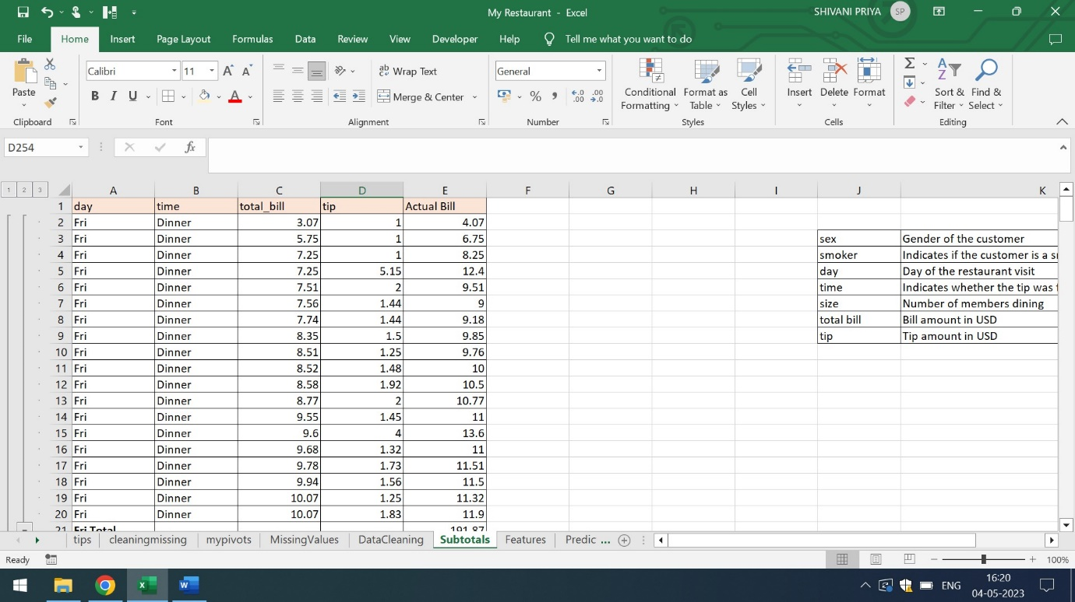

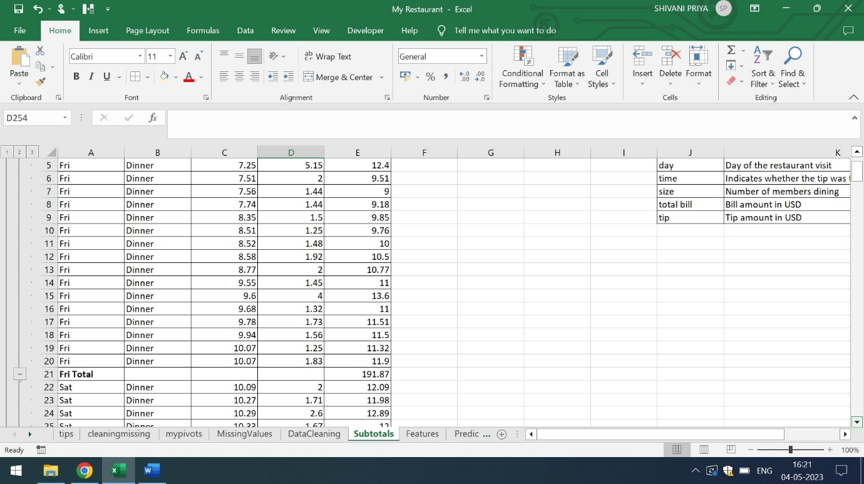

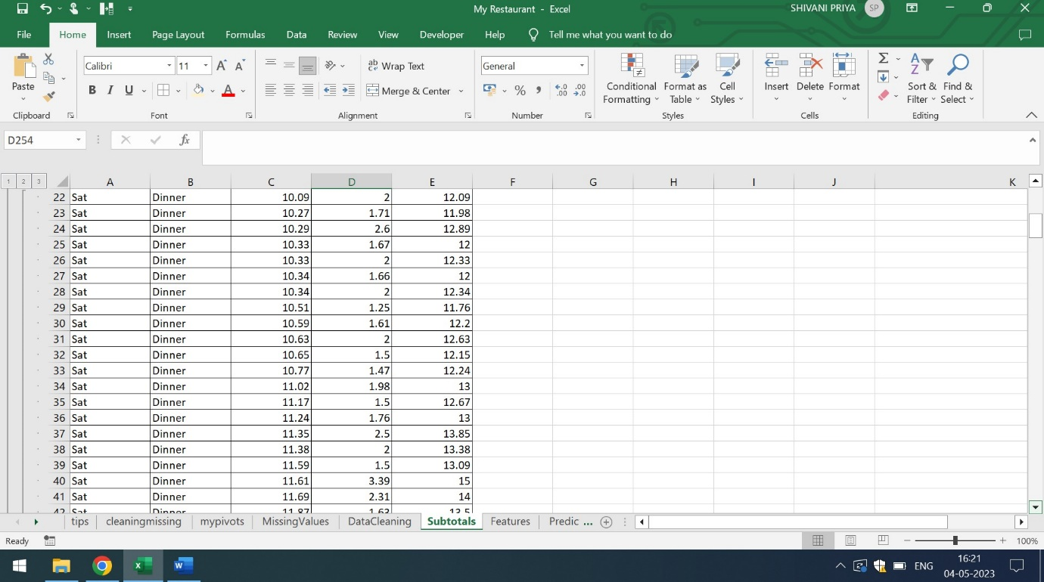

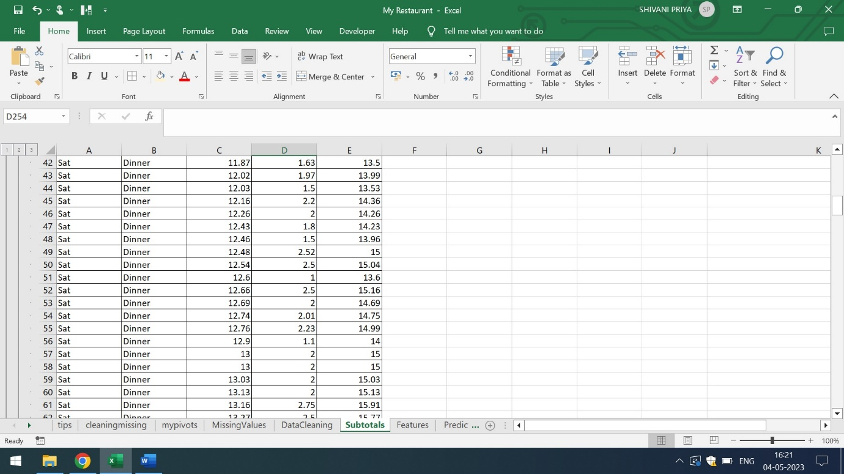

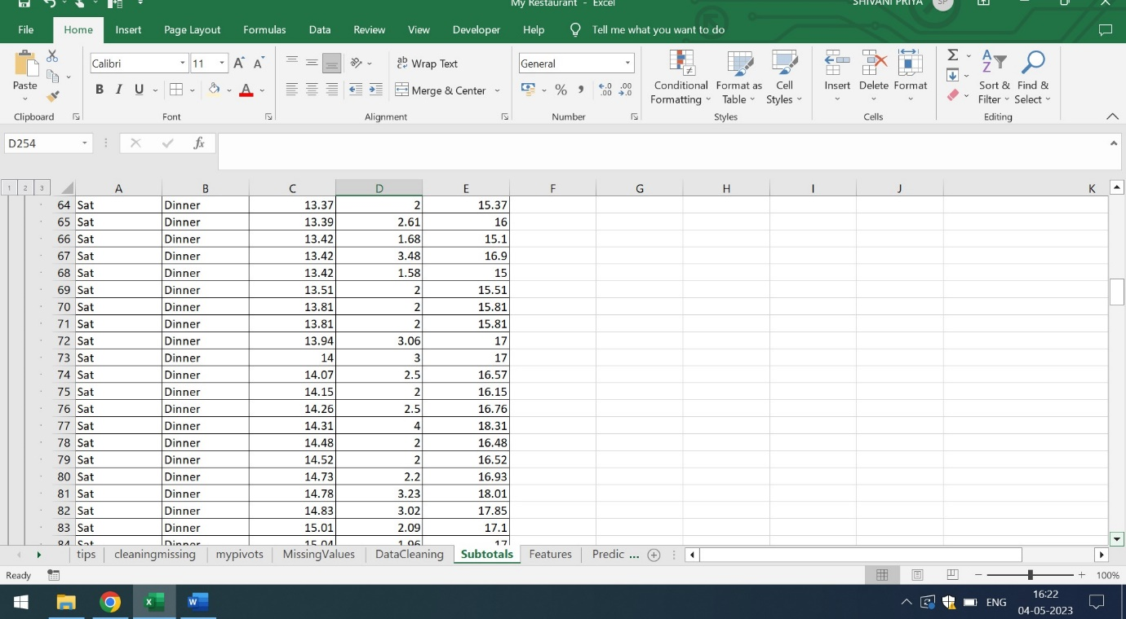

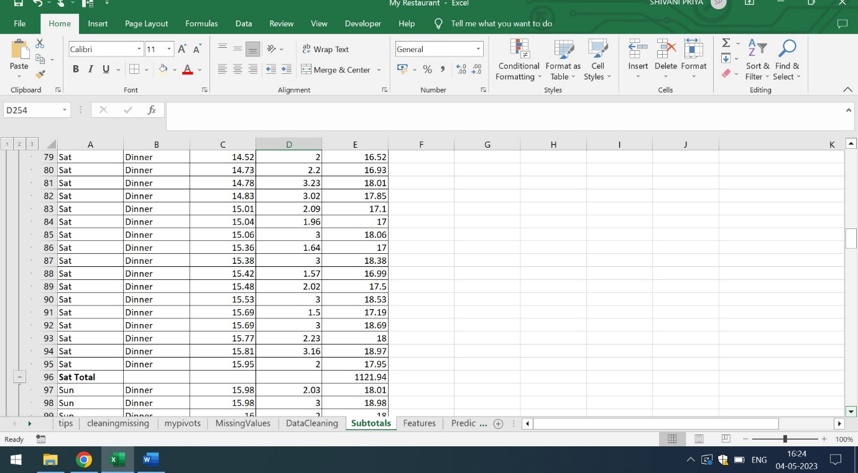

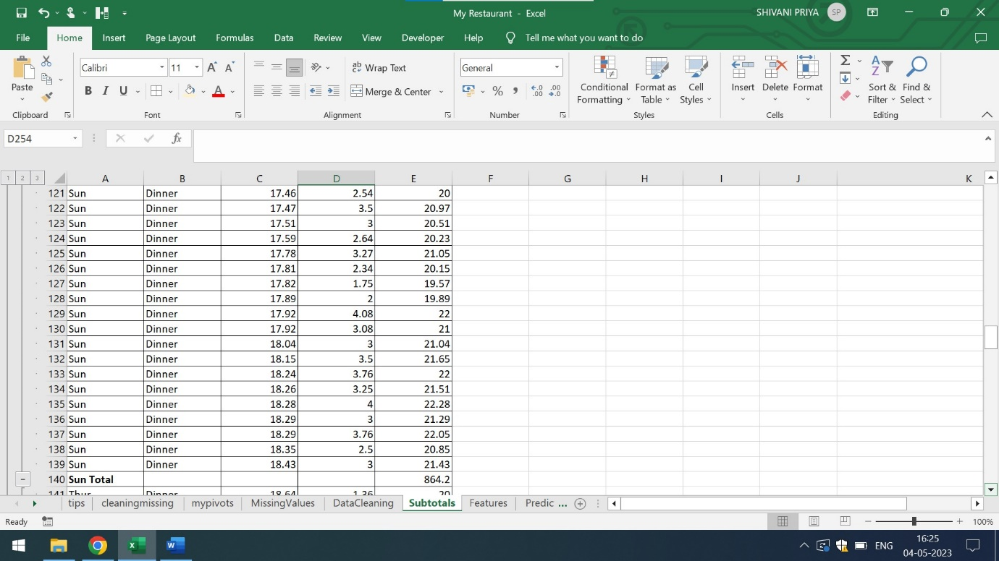

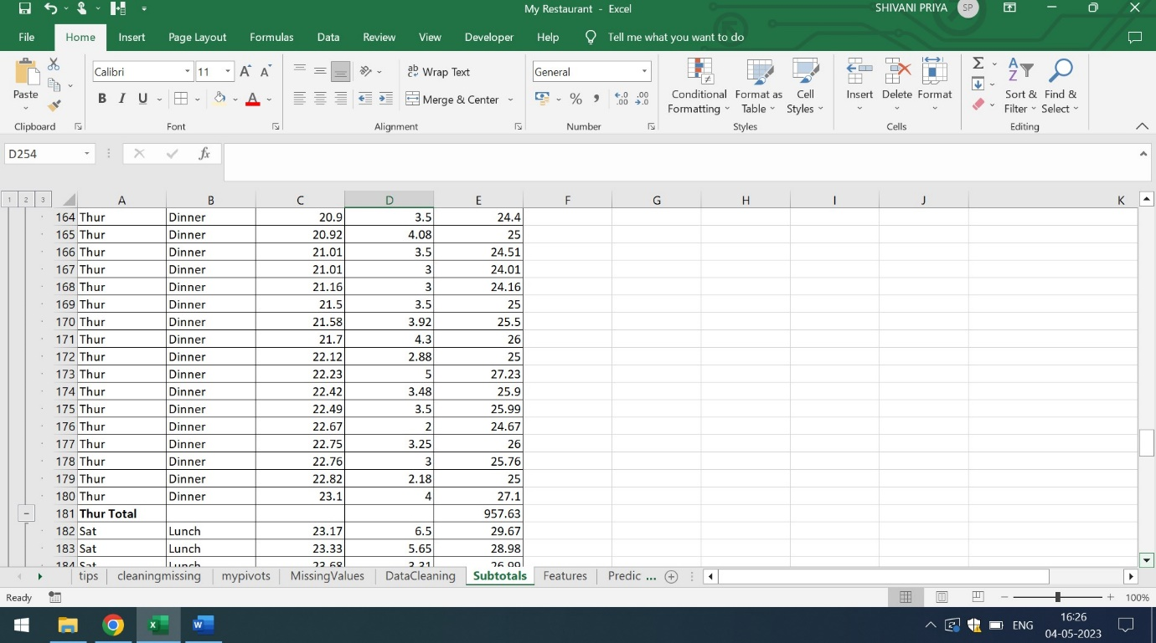

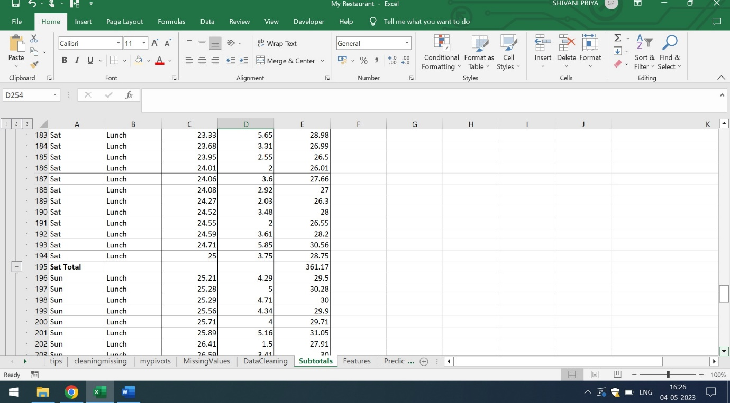

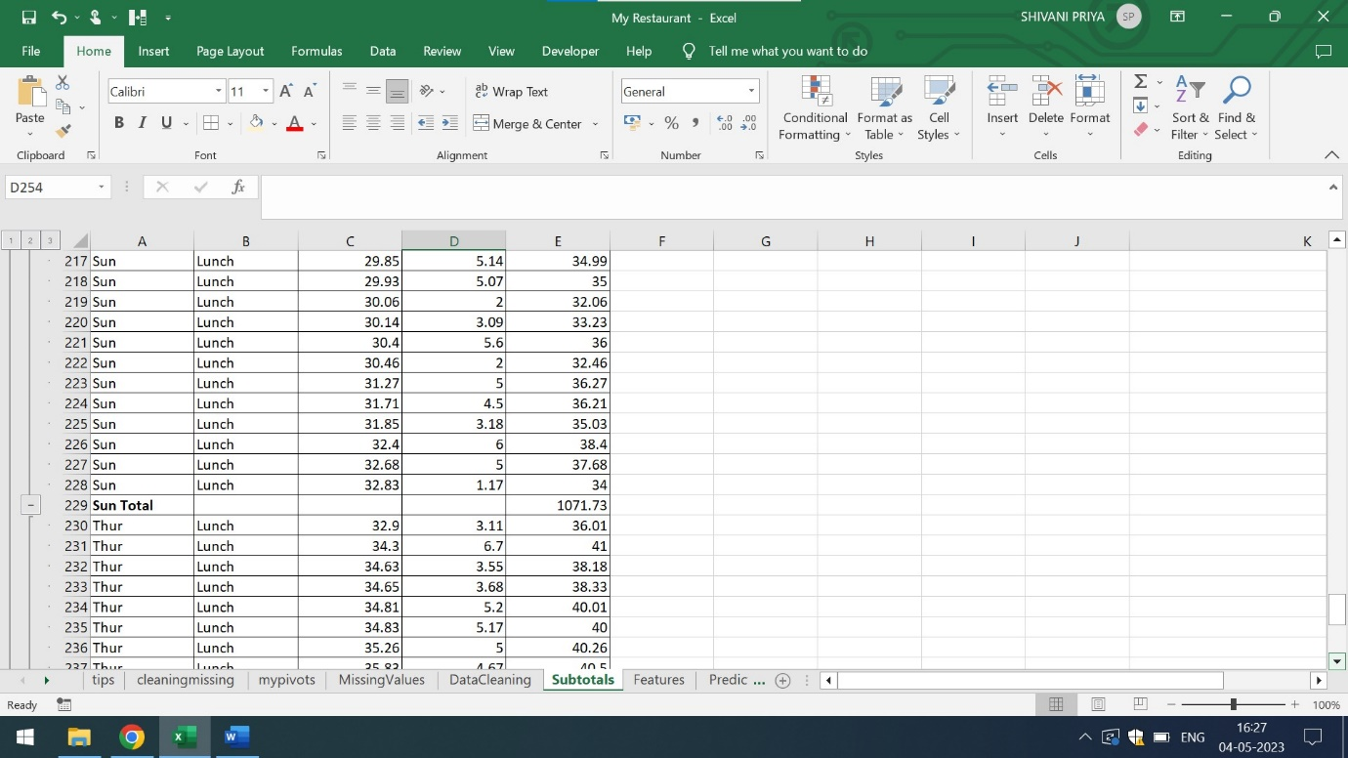

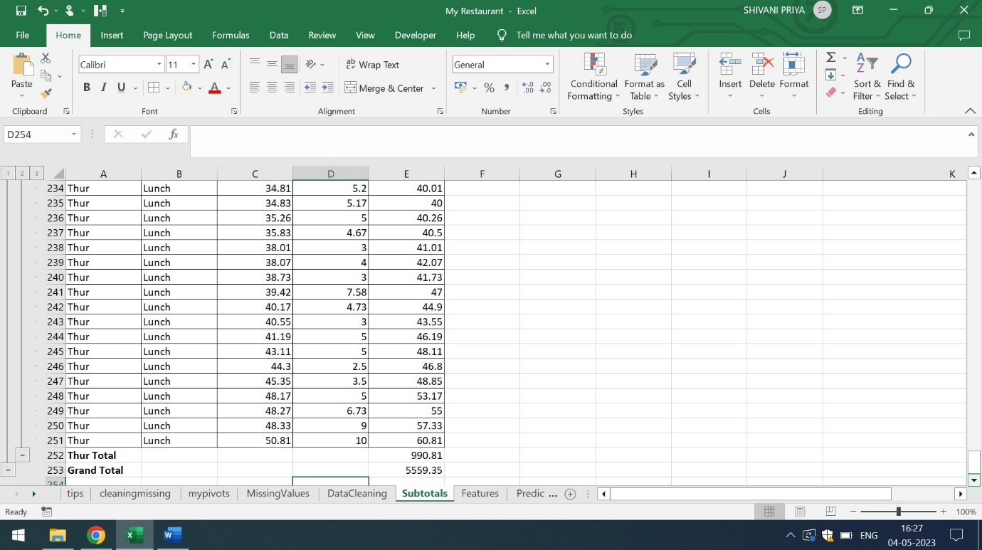

Q3) Find out the features that are independent and dependent

Ans) In the given data set,the independent features are size and tip. Here size is the Number of Members for Dinning and the tip is Tip Amount in USD. The dependent feature is the Actual Bill which is basically the summation of Total Bill and Tip

The below mentioned is the screenshot of Number of Members for Dinning vs Tip

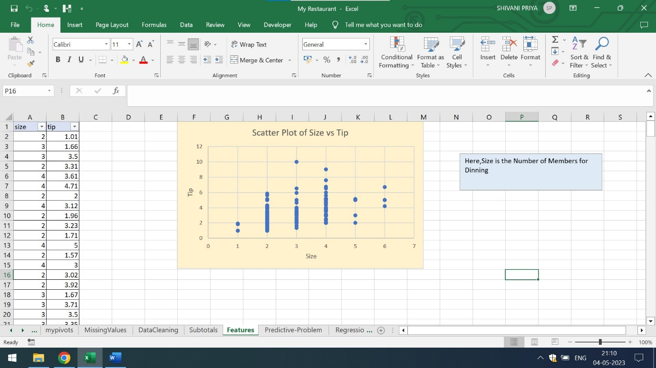

From the above mentioned screenshot, it is clear that when the Number of Members for Dinning is 1,the tip is the range from 1 to 2 USD,when the number of Members for Dinning is 2,the tip is in the range of 1 to 6 USD,when the number of Members for Dinning is 3,the tip is in the range of 1 to 10,when the number of Members for Dinning is 4,the tip is in the range of 2 to 9 USD,when the number of Members for Dinning is 5,the tip is in the range of 2 to 5 USD and when the number of Members for Dinning is 6,the tip is the range of 4 to 7 USD

Q4) Identify which predictive problem is needed

Ans) In the given dataset, for predictive problem analysis I am using the concept of Moving Average,Regression Analysis and Anova Single Factor . The below attached is the screenshot of the Moving Average,Regression Analysis and Anova Single Factor. The 10 days Moving Average helps in identifying the irregularities in the data.

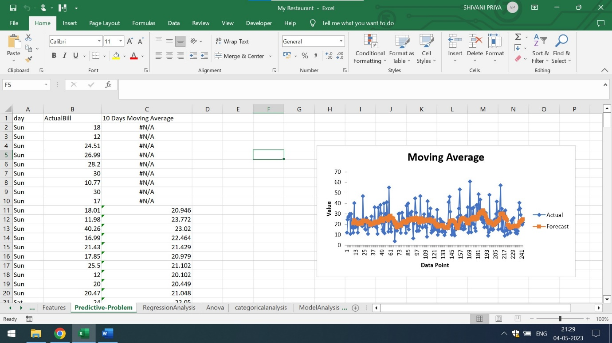

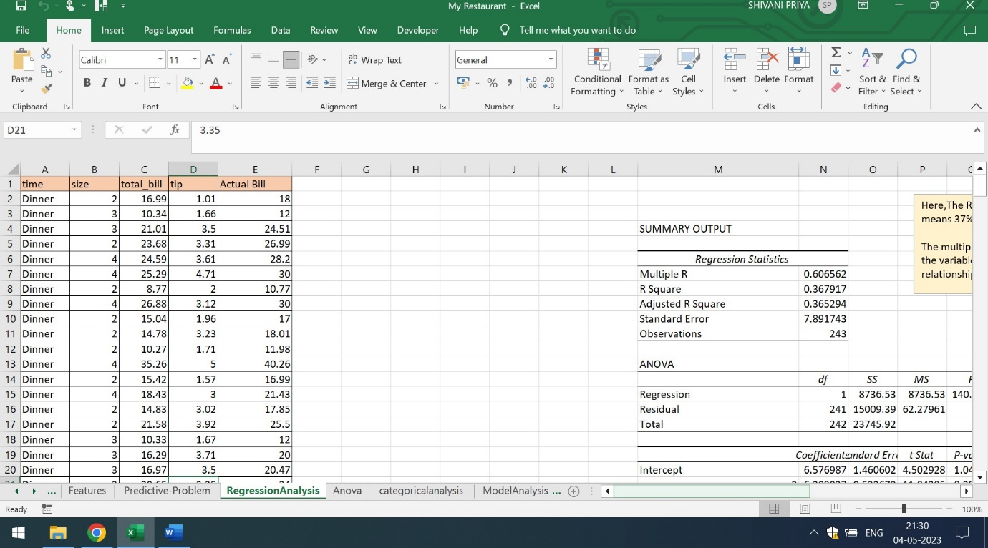

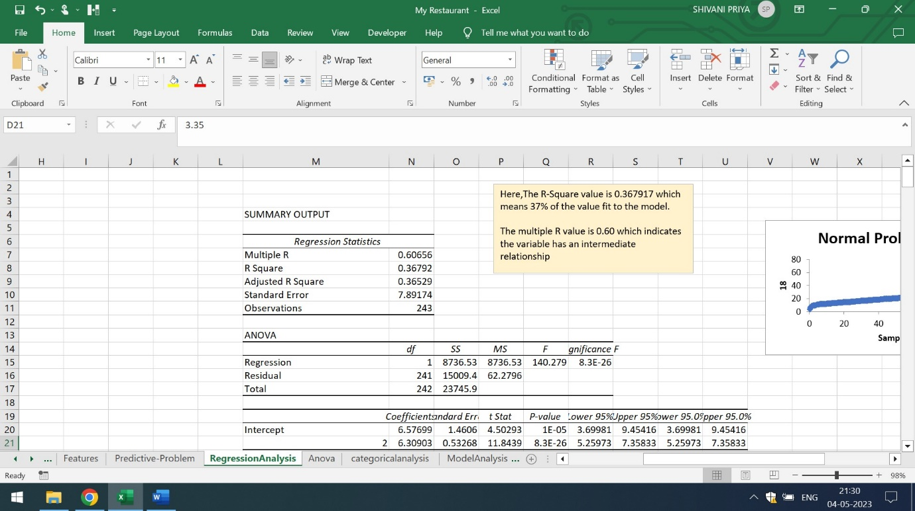

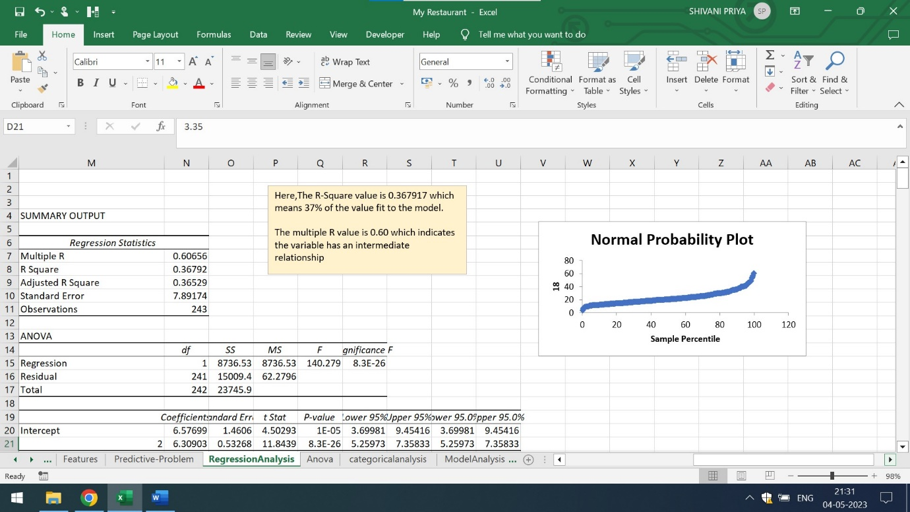

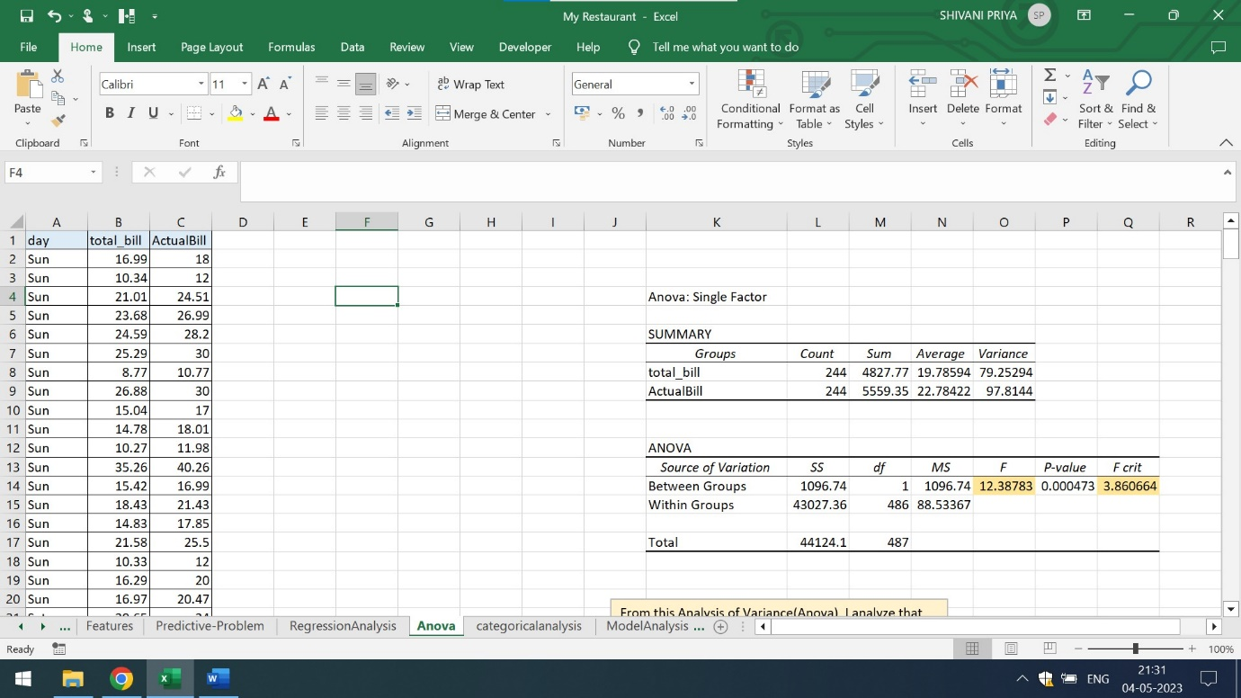

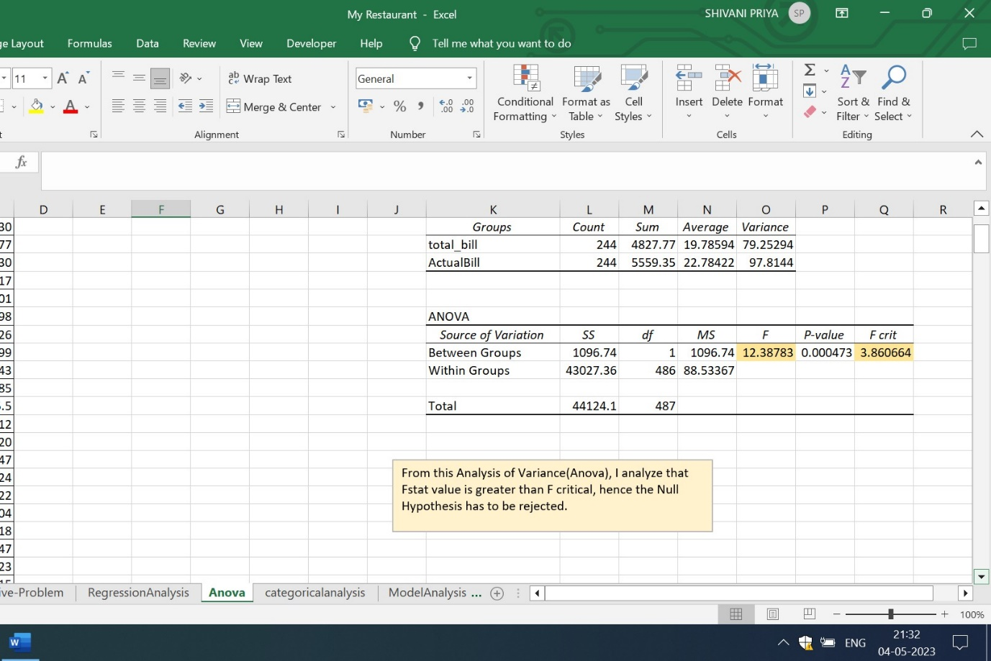

Q5) Encode the categorical variables to numerical values using IF condition

Ans) Here, I am using the column time as one of the categorical column.It has two different groups of lunch and Dinner. There are two formulas of Nested If and If And which has to be use on column tip for predicted tip analysis.

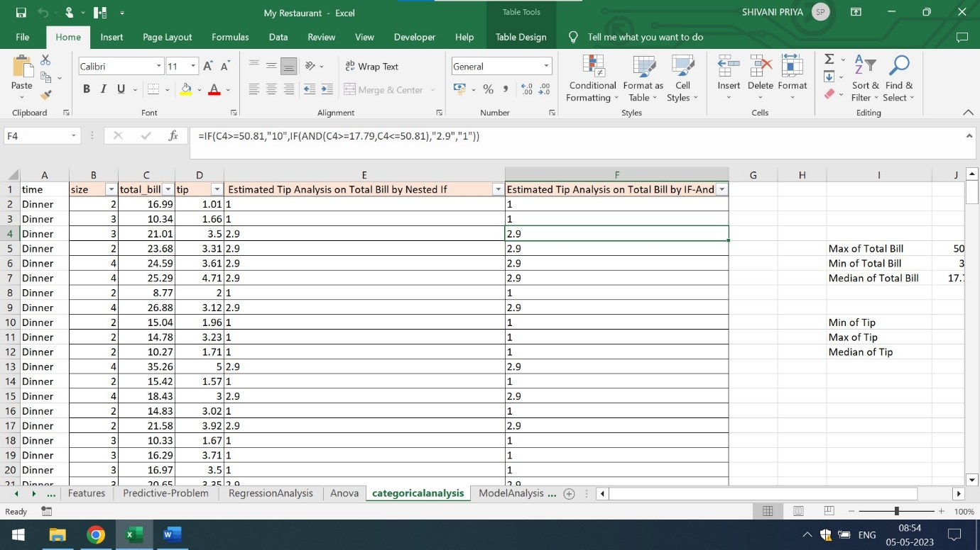



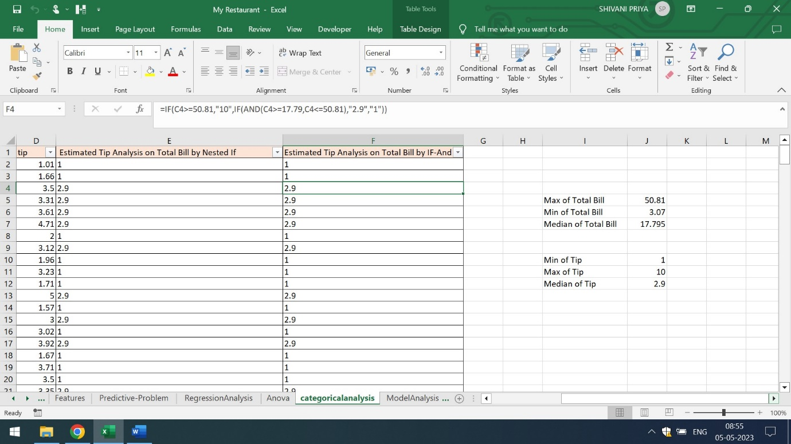

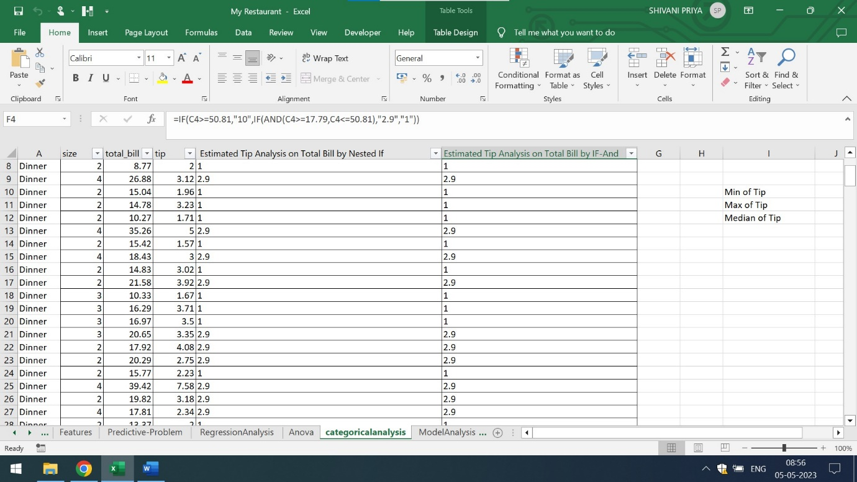

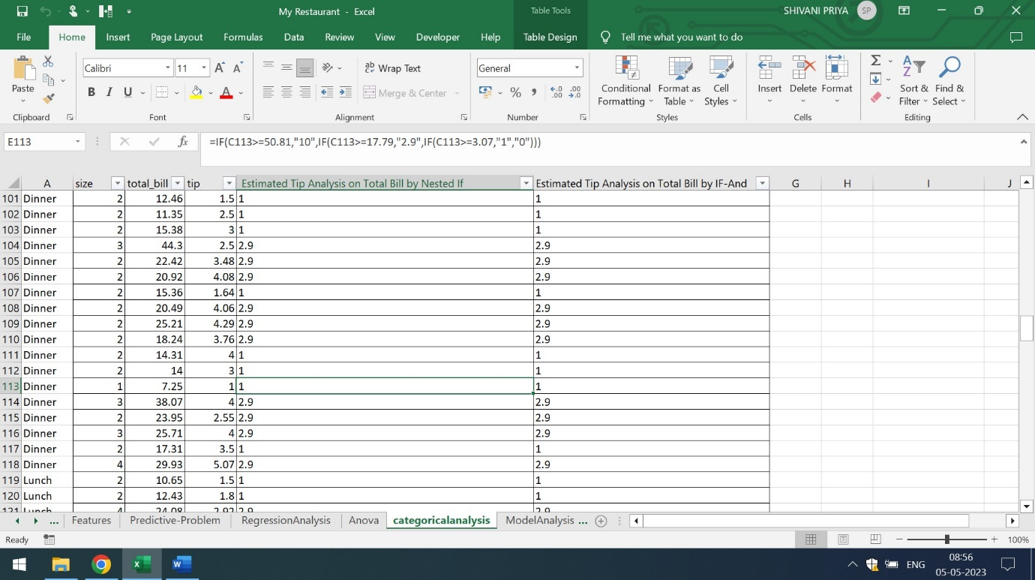

By using Nested If or If And Formula on Total Bill,one can easily analyze that customers are giving 10 dollar when the bill is not more than 51 USD,the tip amount is somewhere around 2.9 dollar when the bill is not more than 18 USD and the tip is 1 USD when the bill is not less than 3.07

Q6) Build an appropriate model with the data set

Ans) Pivot table is the best model with the given data set.Here,Pivot table is used for the analysis of Sum of Total Bill,Smoker Count,Number of Customers for Dinning,Sum of Actual Bill and Sum of Tip. The below attached is the screenshot of the Pivot Table

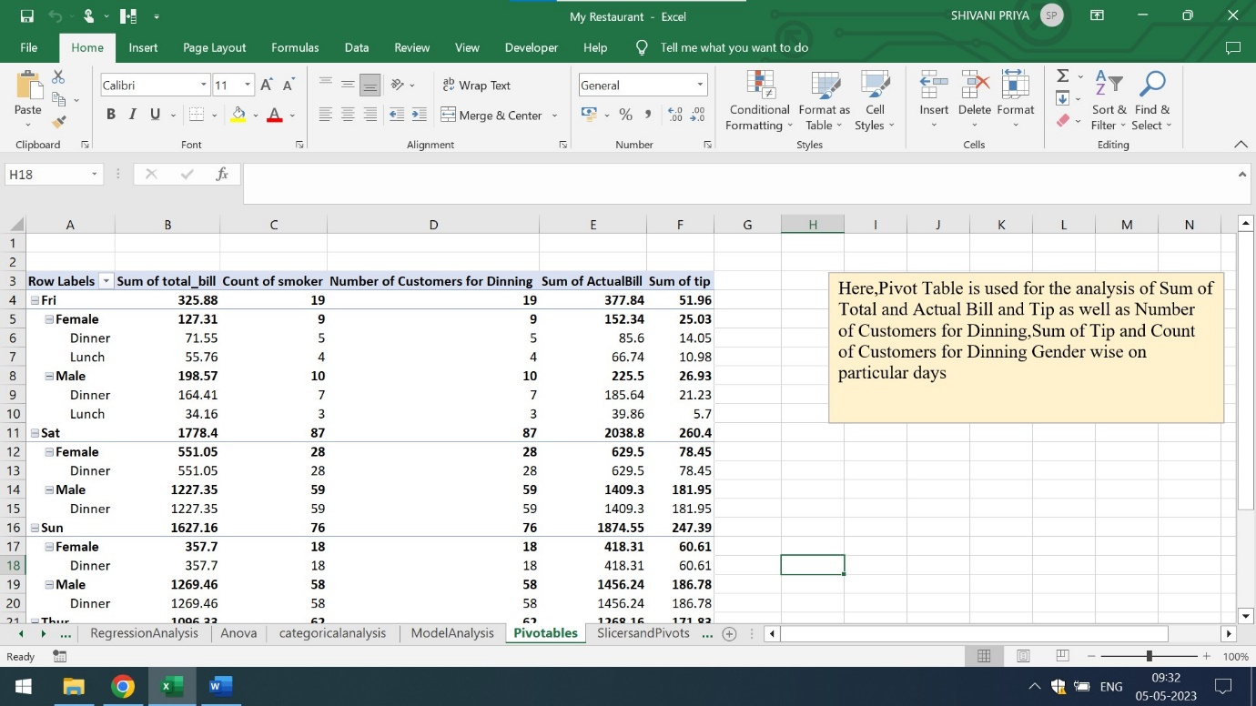

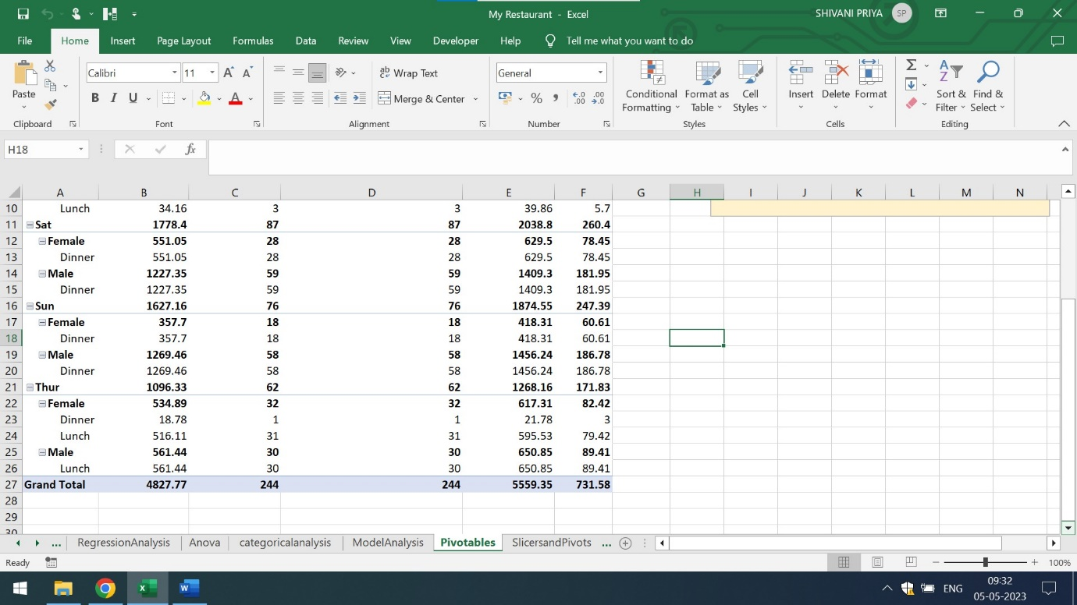

Slicers can also be used with Pivot tables for filtering the results from the pivot table.The below attached are the screenshots of the slicers

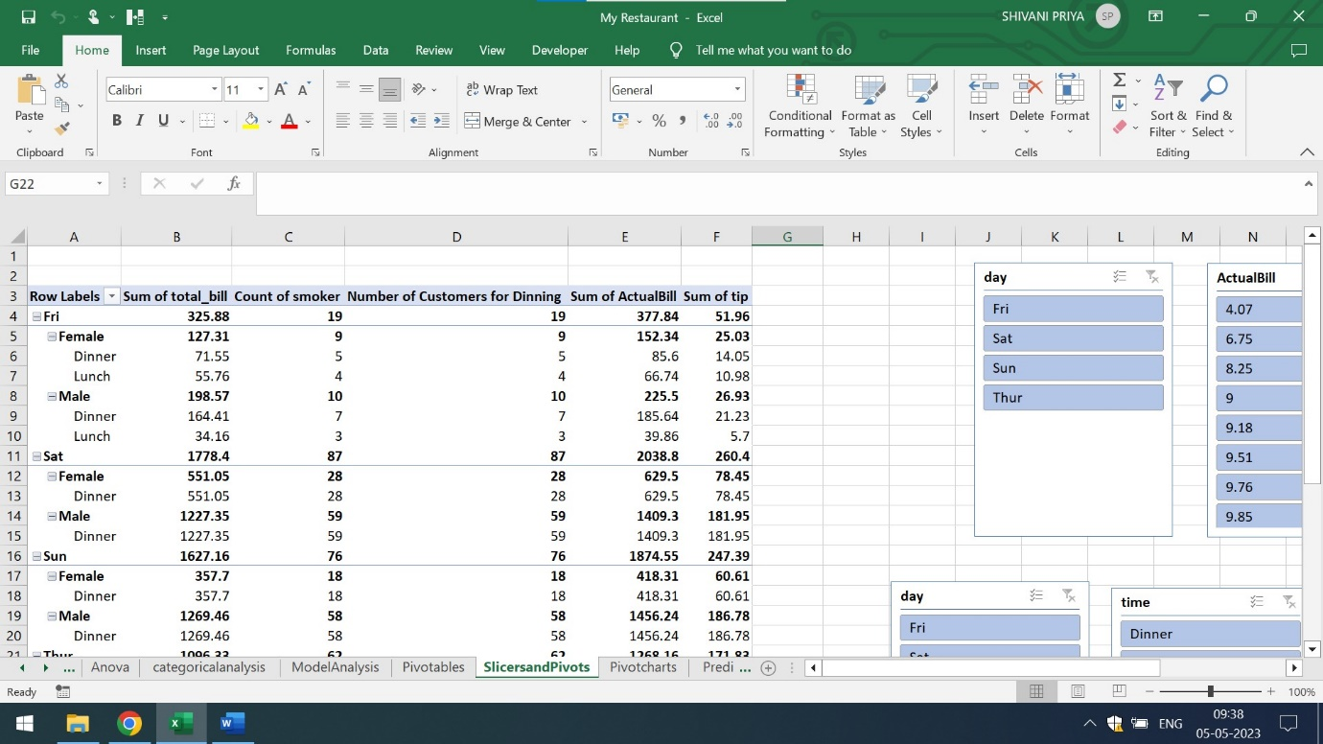

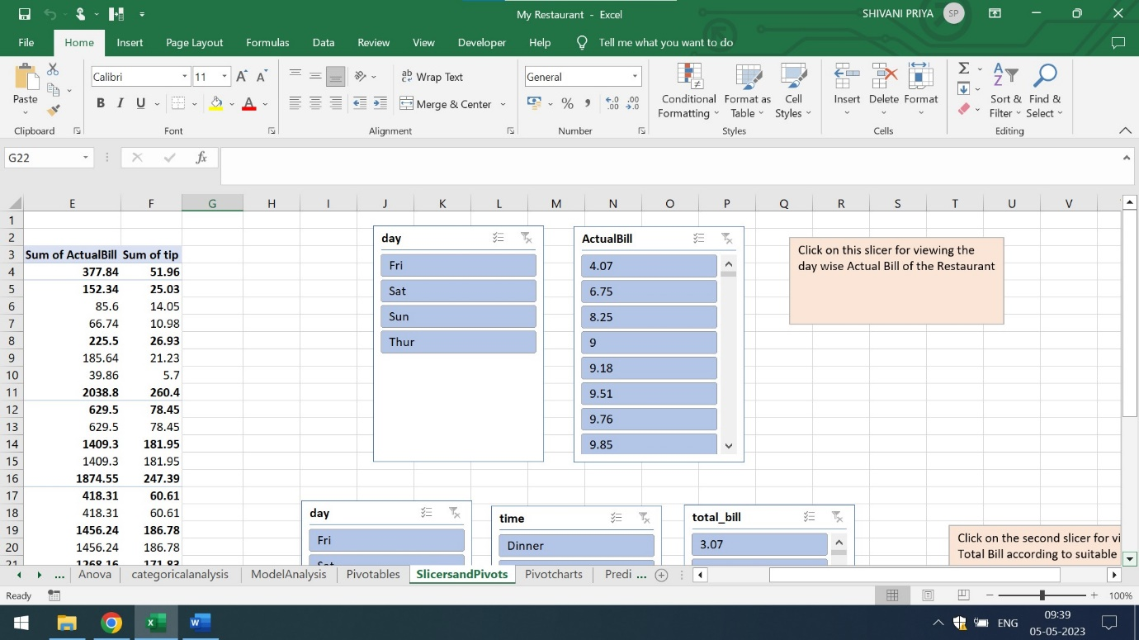

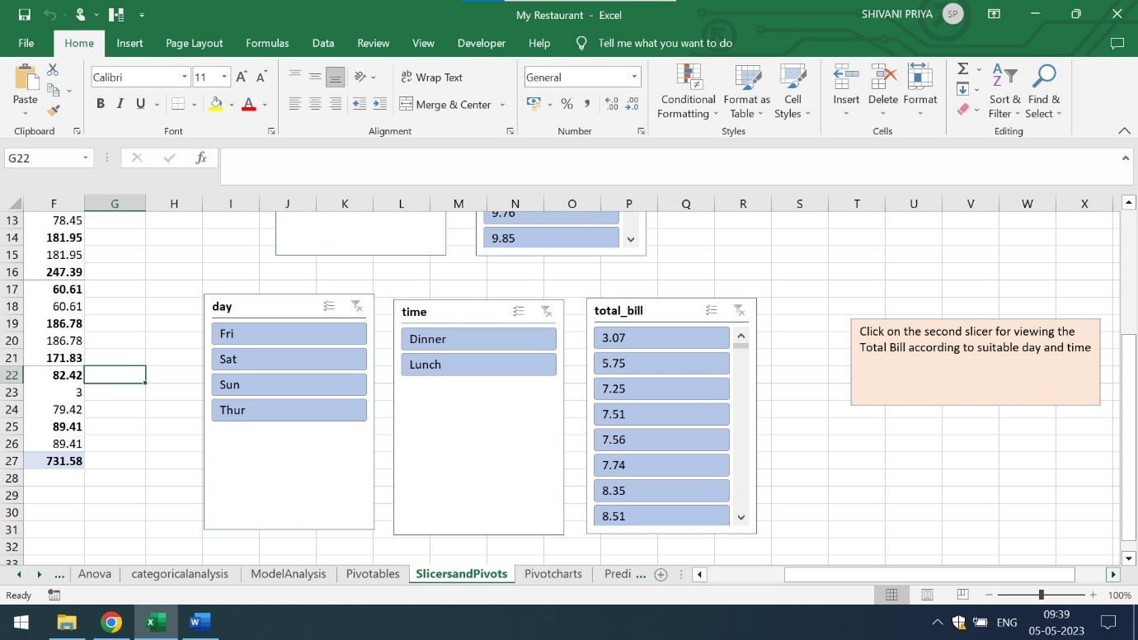

For example,for viewing the total bill of Thursday Dinner,one may click on slicer as it will filter out the results

The total bill of Thursday dinner is 18.78 USD

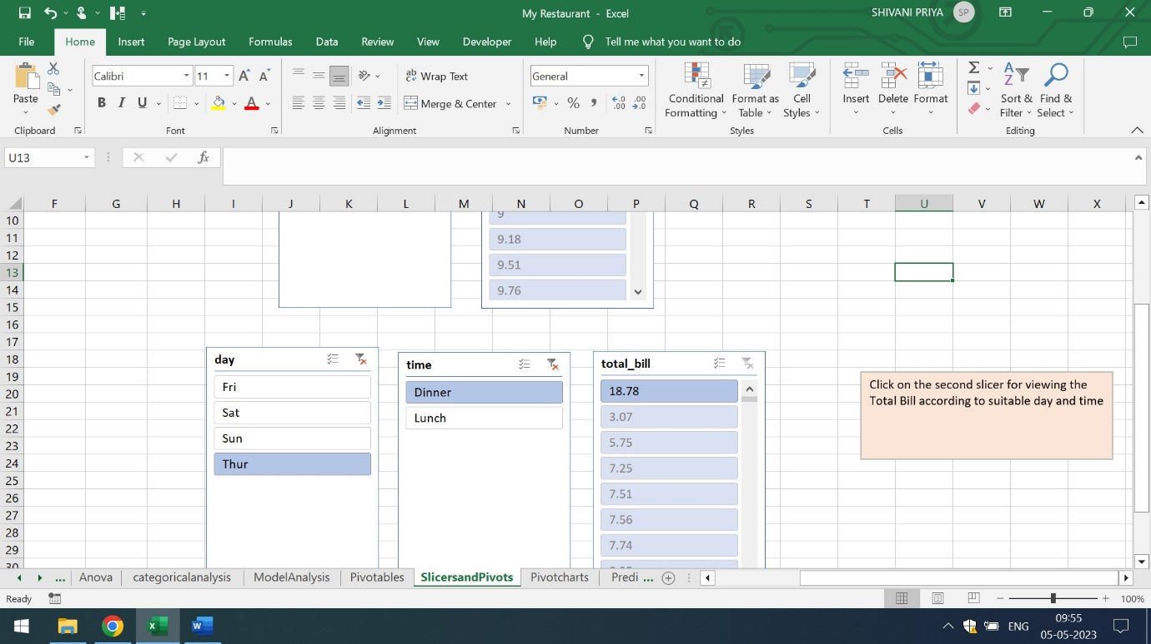

Pivot charts are also helpful for analysis of Sum of Total Bill,Smoker Count,Number of Customers for Dinning,Sum of Actual Bill and Sum of Tip based on Gender wise on a particular day. The below attached is the screenshot of the Pivot Chart

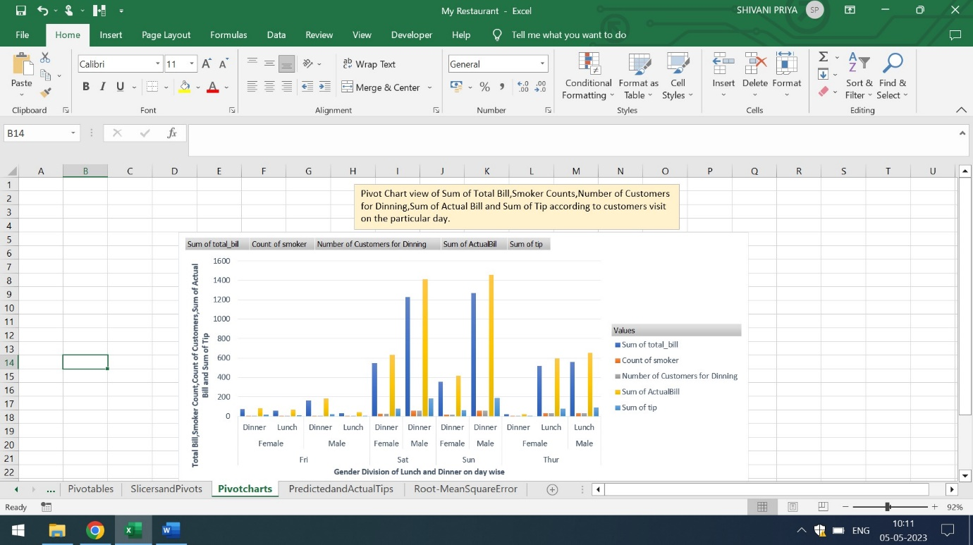

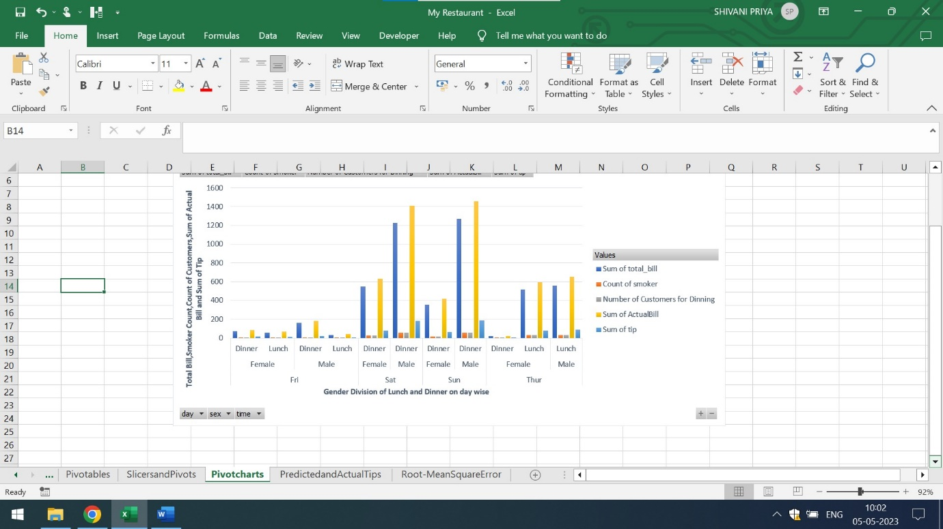

Q7) Calculate the Predicted and Actual Value Tips

Ans) The below attached is the screenshot which shows the actual and predicted tip. The column G is the actual tip while the column H is the predicted tip

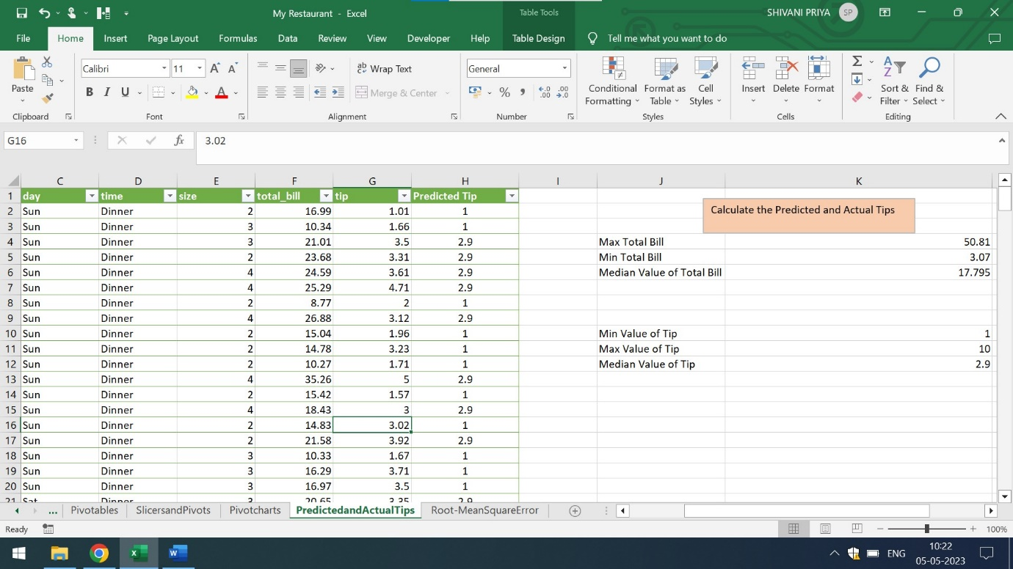

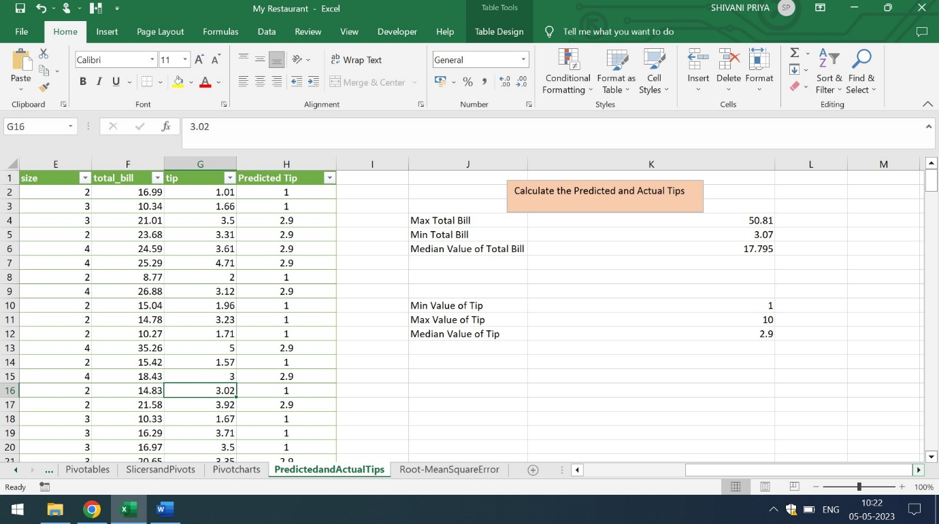

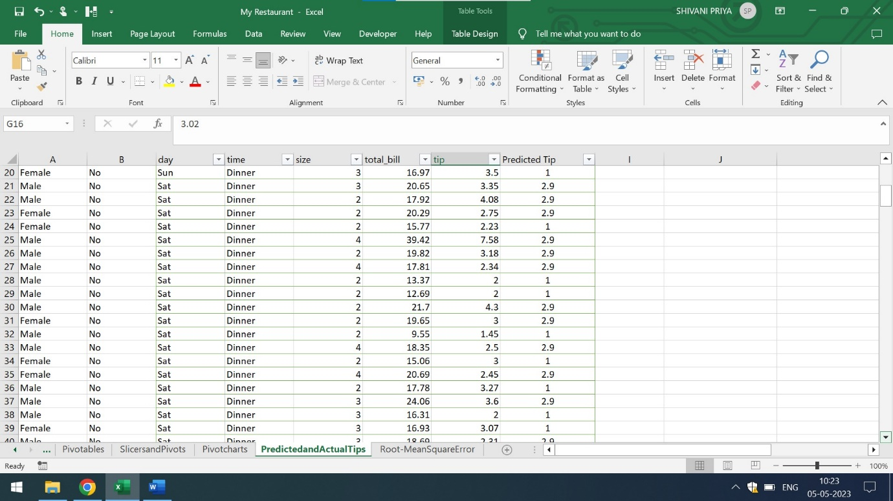

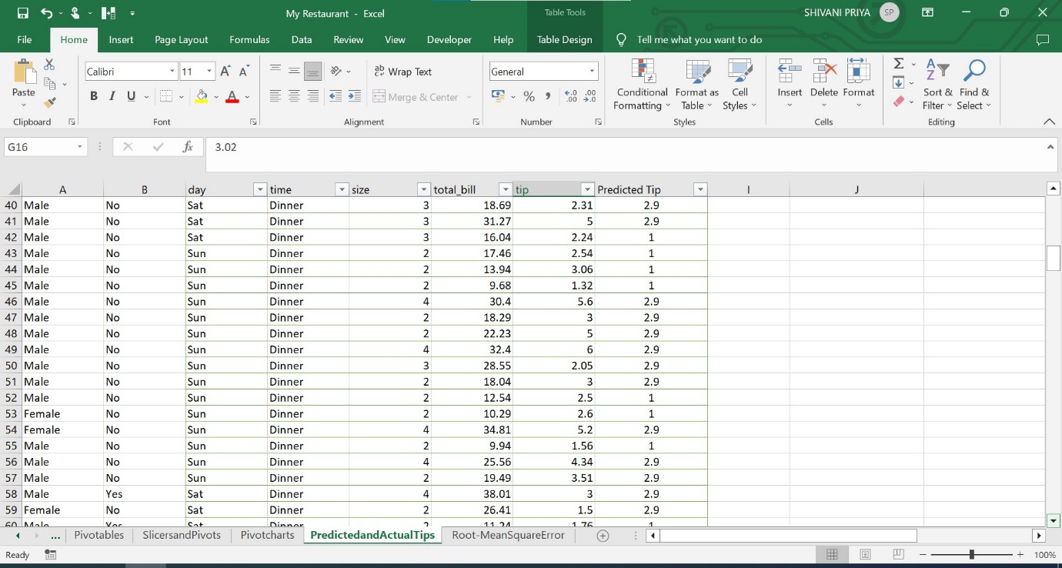

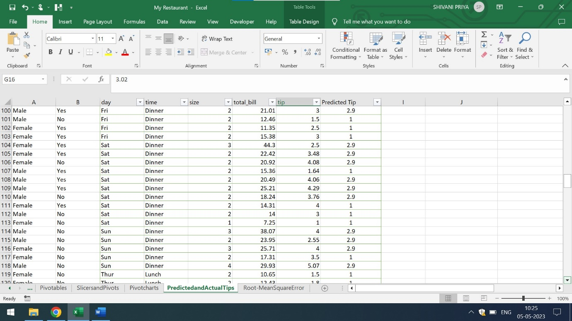

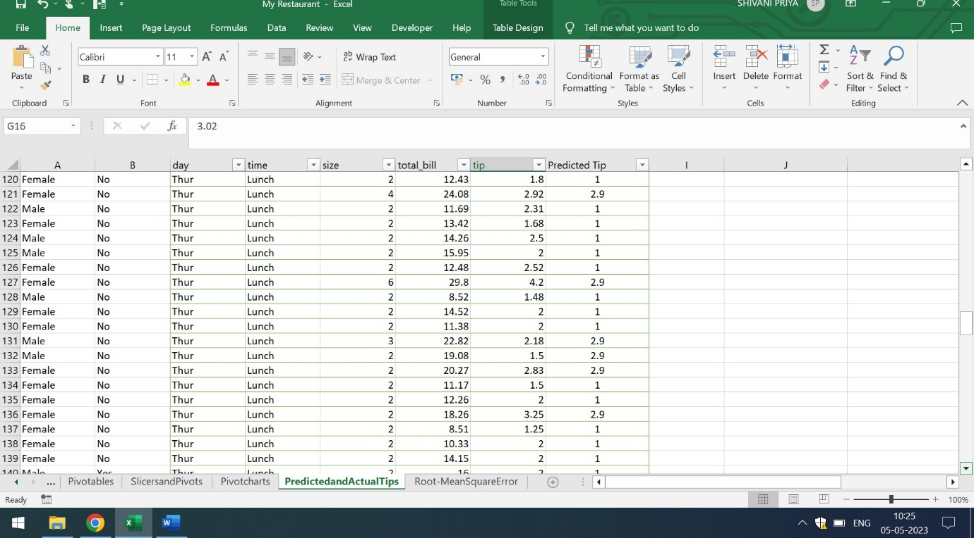

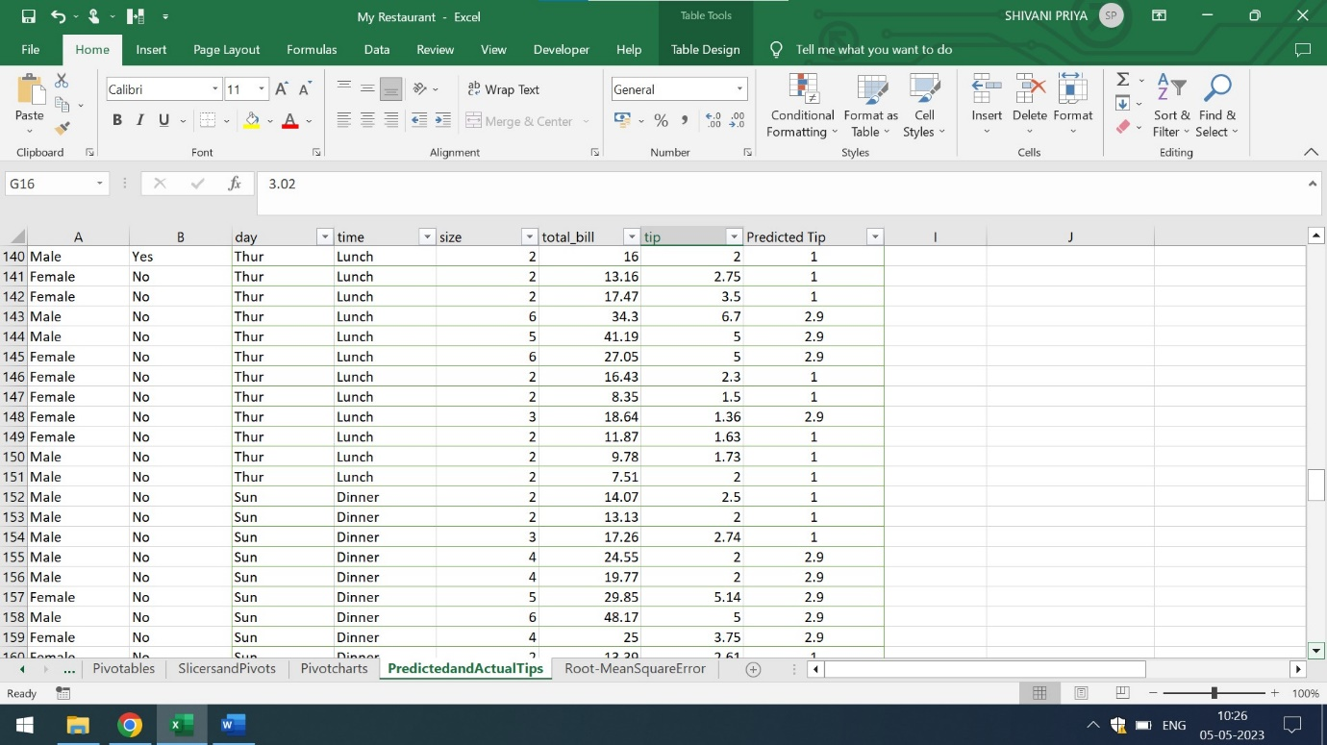



x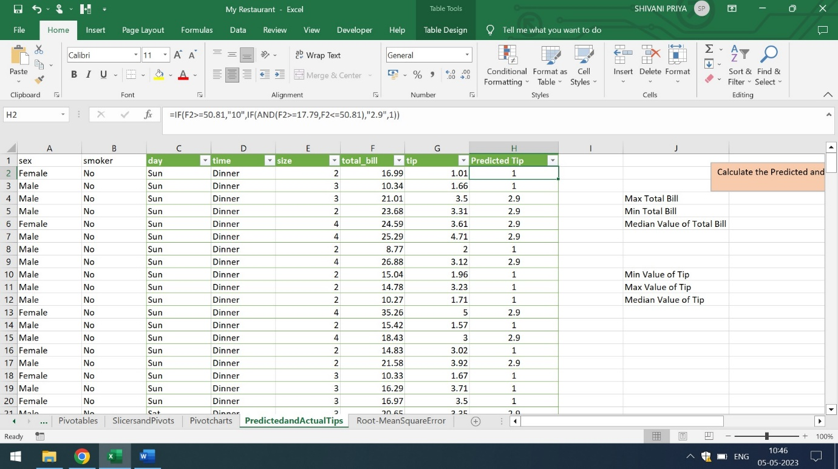

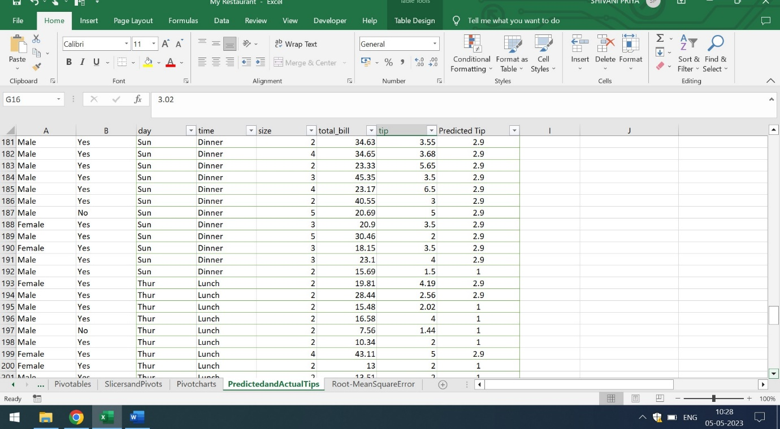

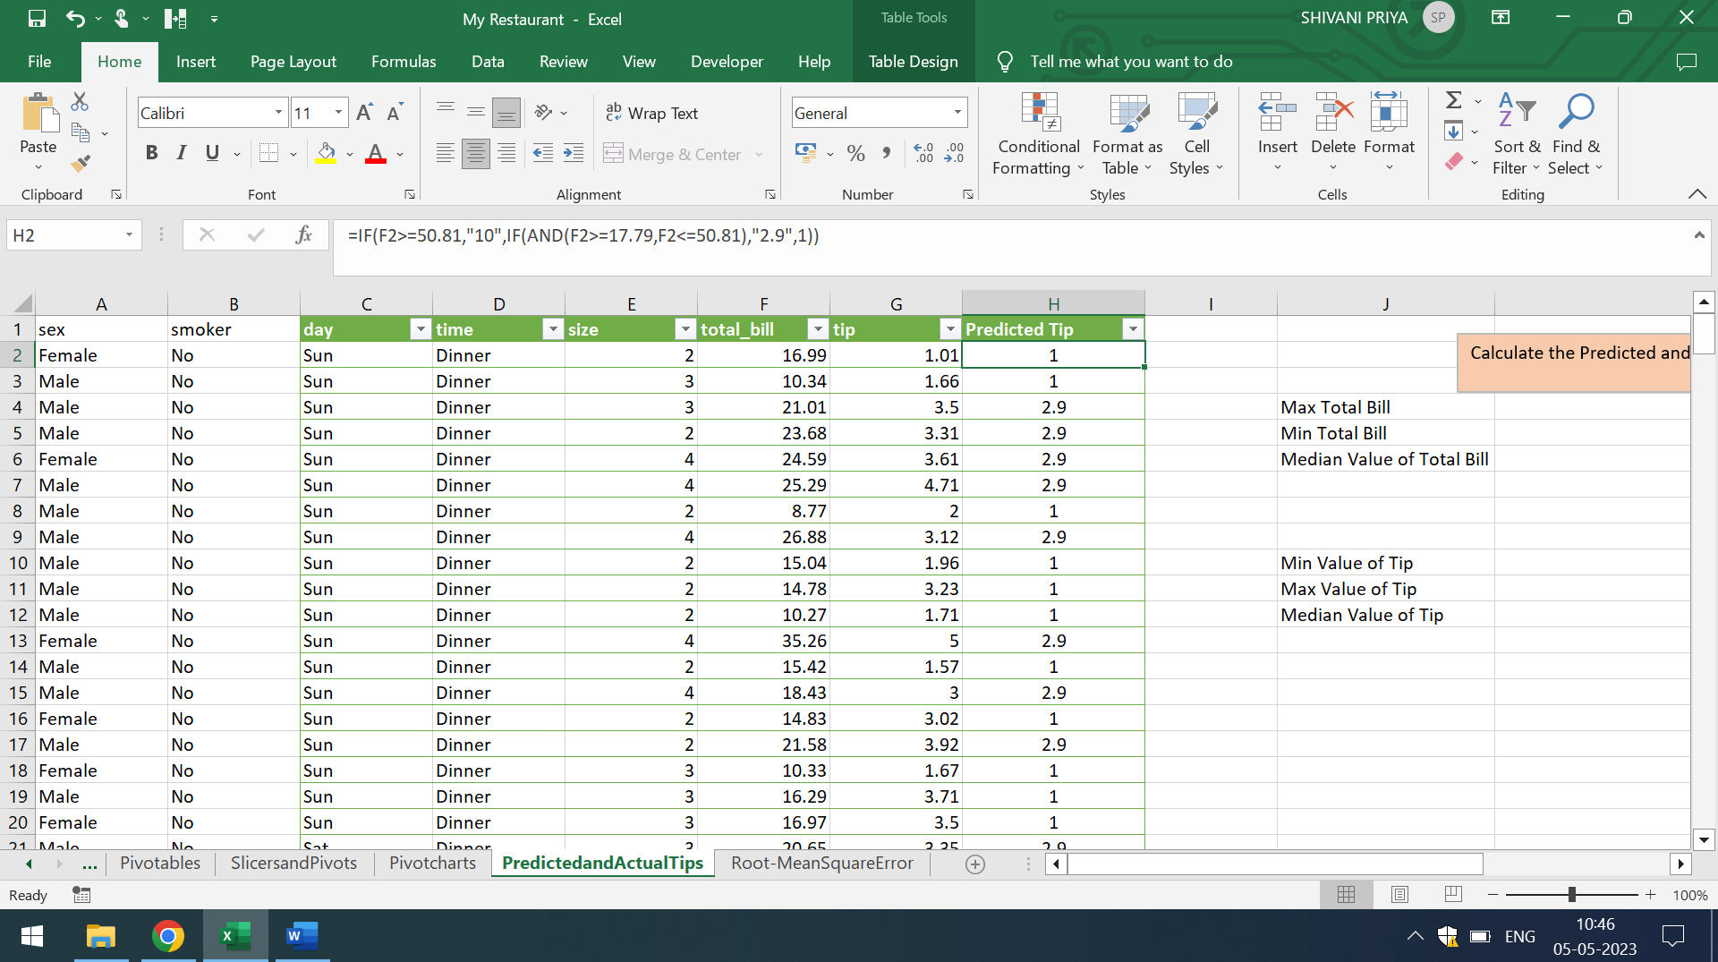

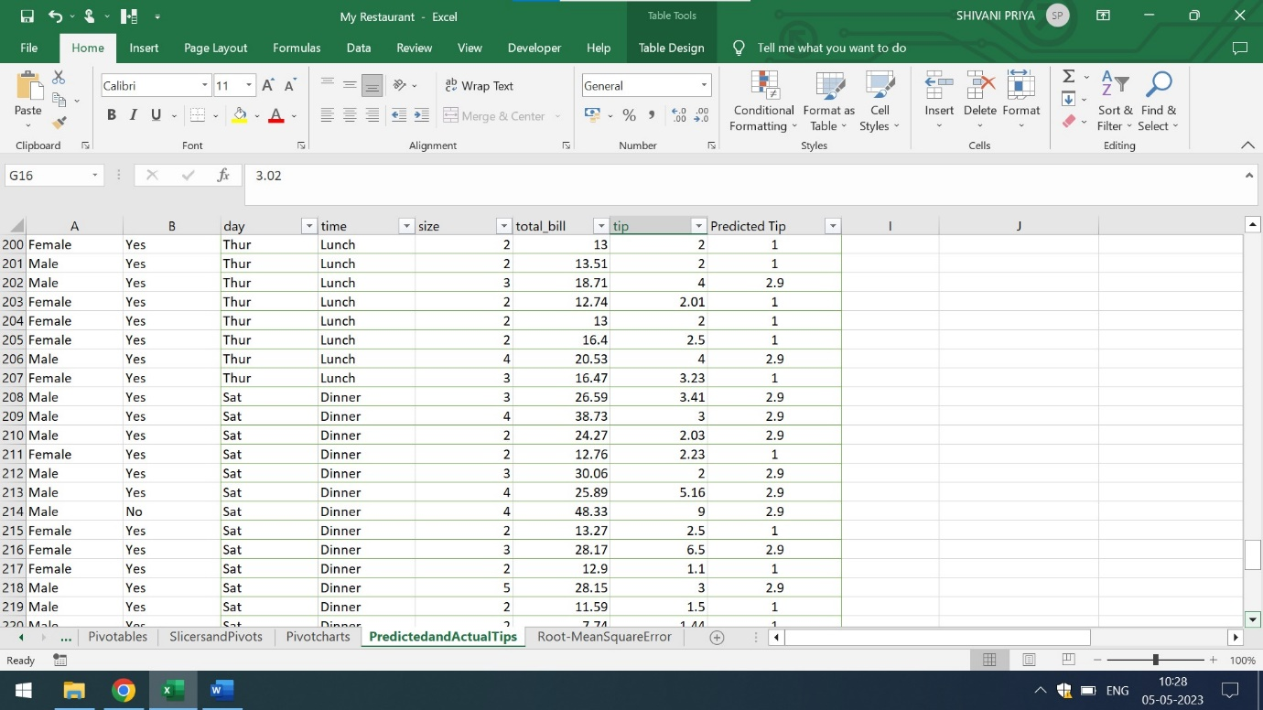

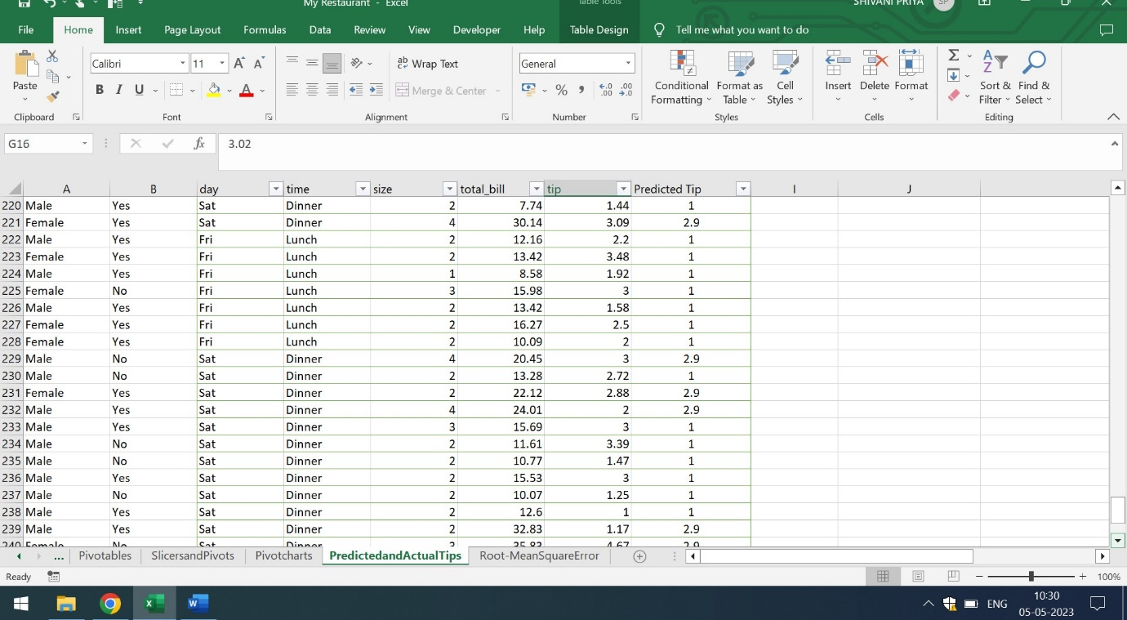

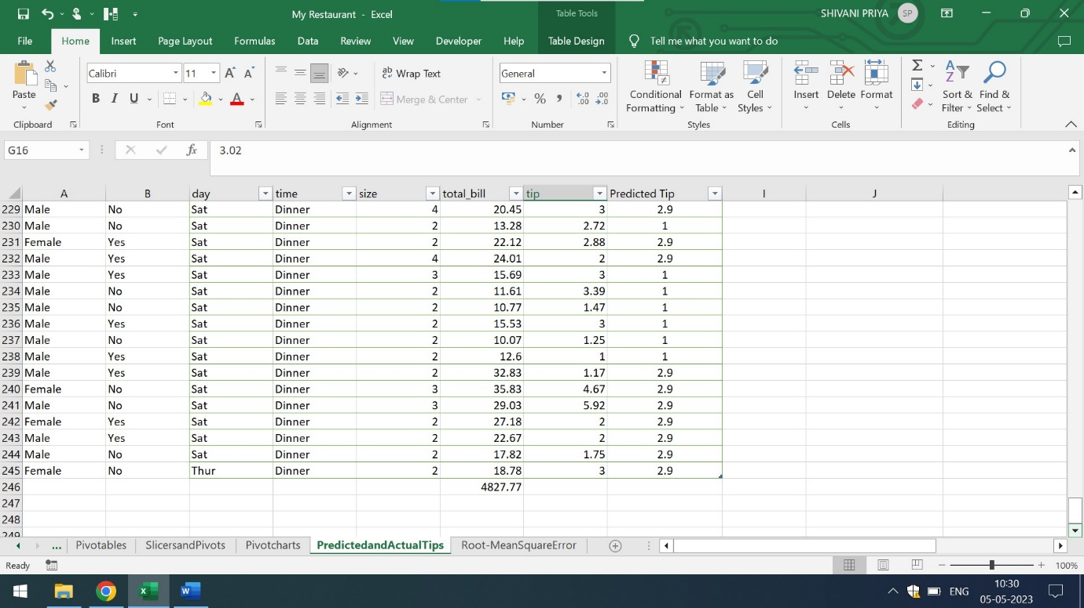

By using If And formula,one can easily analyze that there is not much difference between actual tip and predicted tip.

Q8) Calculate the RMSE(Root Mean Square Error) of the model. RMSE is root of mean of square errors.

Ans) By using Regression in Data Analysis Tab, one can calculate the adjusted R-Square and standard errors

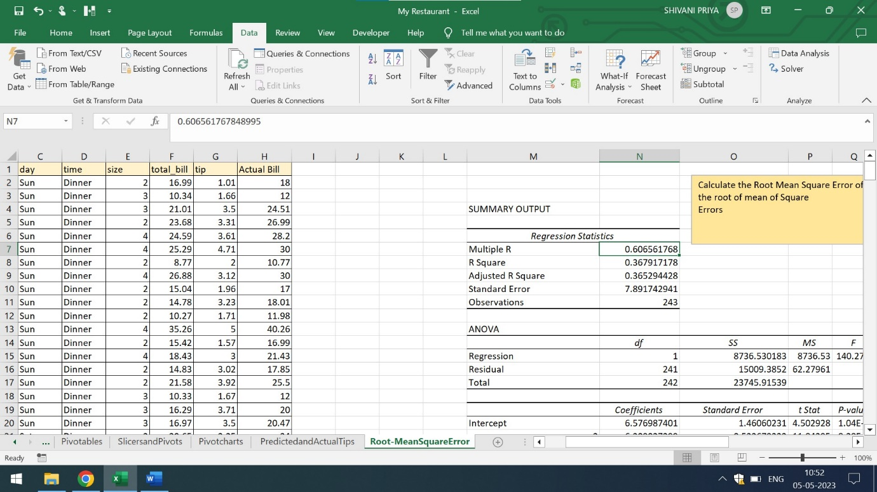

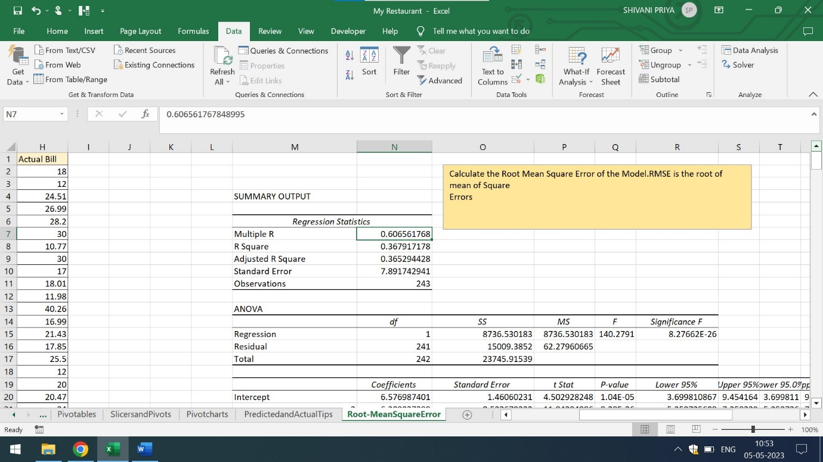



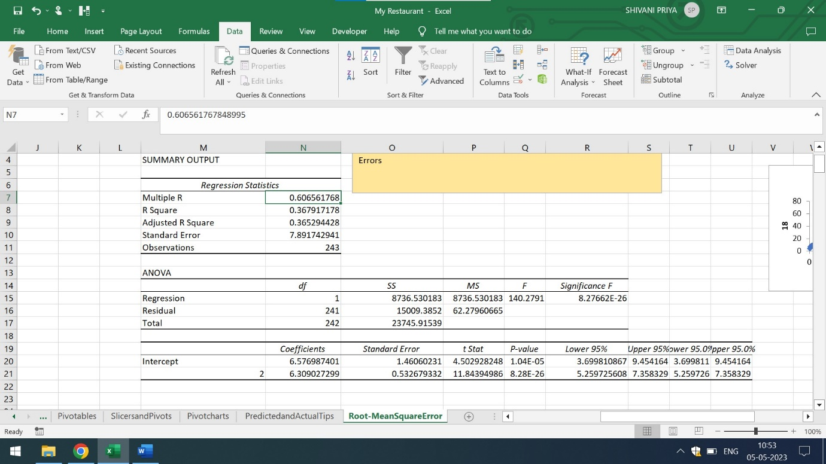

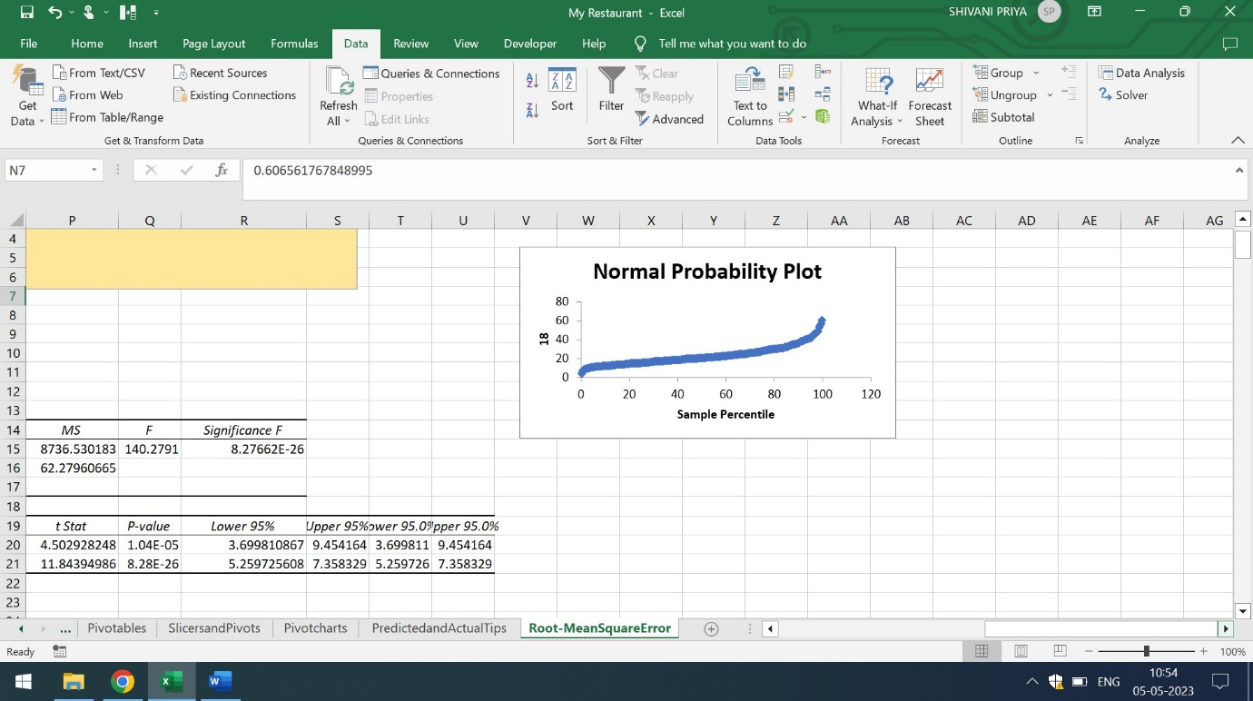

For more detailed information,click on the below mentioned link for detailed report

<https://github.com/shivanipriya89/Restaurant-Tips>